Chapter | Requirements Analysis
1 | Requirements Analysis

1.1 Objectives
The objectives are as follows, to carry out a detailed system analysis. Firstly identifying and defining the problem. Then investigating a current system followed by a proposed solution to the problem. Finally, identify what the new system must achieve.

1.2 Scope
This software project has been described as “Asteroids”. The actual system itself will also be known as “Asteroids”. The following sections will list the problems and the proposed solution.

1.3 Problem Definition
There have been many versions of the classic computer game “Asteroids”. A lot of these versions have been implemented with the idea of a single player. It is desirable that a multiplayer version be implemented.
The project will involve the creation of a client/server system. The user will be able to move their spaceship around the gaming area and shoot other players and asteroids (which float randomly around the game).

1.4 Formalising the problem definition
- What is the motivation for the system?
The system will enable multiple users to battle against each other in a bid to win the game.
- Who will use the system?
The system is primarily aimed at computer game enthusiasts.
- When is the system required?
A fully functional system should be delivered by 19th April 2002.

1.5 Analysis of the current system
The proposed system is not an improvement to any current system; analysis will be made on an already existing system. The system being studied is located at http://www.arcadepod.com/, and is called “Asteroids”. There was no multiplayer version available, so the system being studied is a single player game.
- Ship
Ship movement works very well, the keyboard is used to maneuver your ship, destroying as many asteroids as you can while avoiding collision with them.
- Asteroids
There are two kinds of asteroids, big asteroids and small asteroids. They move at a random velocity with the smaller asteroids having a greater speed.
- Score
Your score is displayed along with a top score for the current session.
- Lives
Number of lives is displayed. You start with 3 lives in this system.
- Sounds
This system has sounds implemented, they can be turned off and on.

1.6 Proposed System
- The proposed system is to have a multiplayer version of the “Asteroids” game, that is, have multiple users within the same game.
- The proposed system will be that of a client/server system deploying two-tier architecture (client application and server application).
- The client front-end will look attractive and will be simple to use.
- The proposed system should be flexible so that users can join and leave the game freely.
- The finished system will be known as “Asteroids”.

1.7 System objectives
Usability
Users should find the system easy to use. The system should create a playing environment that establishes viable user match-ups so that novices can play against others with a similar skill level, advanced users can find a challenging game, and users of every other skill level in between can match up with others of like ability.
Fairness and Chance
Game balance should work in such a way that the better player usually wins, but the underdog always has a more than fair chance.
Social Opportunities
Multiplayer gaming is a social experience, and gamers want the chance to play in games with their friends or acquaintances.
Replayability
The proposed system should be “replayable” and have longevity so that users keep coming back.
Performance
The game graphics should be smooth. The system should have a lag-free environment.
Suitability
The system should provide a solution to the problem.
Expansion
The system should be easy to expand on, add new functionality and make modifications.

1.8 Approach
Many programming languages could be used to successfully implement the system, they include:
- Visual Basic
- Java
- C++
1.8.1 Chosen Approach
We want to be able to play the game over a network connection, although C++ and Java can both achieve this, Java will be the language used to implement the system. Mainly because I have a strong knowledge of the programming language, there are also a lot of resources available, and also that creating a client/server application in Java is effortless.

Chapter | Requirements Specification
2 | Requirements Specification

2.1 Objectives and Scope
The objectives are as follows, to produce a requirements document that can be used as a basis for the construction of a software system that delivers the functionality and features require by the required system. The requirements document should form the contract between the user and developer.
Scope
- Level of detail
Restrict the requirements document as much as possible to specify what the system should do rather than how it should do it. The requirements document should be the users’ view of the system rather than say anything about how the system should be implemented.
- To whom the document is addressed to
The specification has to be understood by two different sets of people, the users and the developer.
- Notation used
The user will have preference for informal descriptions expressed in a natural language that describes their viewpoint of the system. However this notation is not enough to produce an unambiguous specification required by the developer.

2.2 Functional Requirements

2.2.1 Server Side Functionality

When the server is ran. It waits to read in requests from the client.
- The server then reacts to the request issued by the client by performing the necessary calculations.
- The results are sent back to the client and the client reacts to the data sent by the server.
- The game will be access from a webpage.
- The time the server responds to client requests should be kept to a minimum

2.2.2 Client Side Functionality
- When the client is first run it tries to connect to the Asteroids server.
- The client waits for a key press. Upon a key press it sends the necessary information to the server.
- The client reads in data from the server and reacts accordingly.
- The client will update the game area with the relative information sent from the server.
- The client will download the game from a webpage hosted on the server side.
- The time the client responds to server requests should be kept to a minimum

2.2.3 Gaming play area
- This is where the game will actually take part.
- It is a predefined area, and is not scrollable.
- If your ship or asteroid goes through the side of the playing area, it will re-appear on the opposite side that it went through.

2.2.4 Gaming area background
- It will be a black background with white pixels.

2.2.5 Asteroids
- They will move over the gaming play area in a straight line with random velocities.
- The asteroids cannot collide with each other, they will just move over the top of each other.
- If an asteroid moves off the playing area it will reappear on the opposite side it went off.
- When these are shot, the big asteroid split into two smaller asteroids.
- When the smaller asteroid is shot, it disappears off the playing area.

2.2.6 Spaceships
- The ship will be able to move around in a complete circle and will be able to accelerate
- To decelerate you must face in the opposite direction and accelerate
- When you first join game or lose a life you become invincible for a set amount of time

2.2.7 Modes of Play
- Each spaceship will have a unique colour
- Each spaceship will have a unique colour of laser. This will be the same colour of the spaceship
- A user will be removed from the game when all their lives are used up.
- The last man standing will be awarded the winner

2.2.8 Scoring Modes
- When you shoot the big asteroid you will receive 30points
- When you shoot the small asteroid you will be awarded 40 points
- When you shoot an opponent you receive 100 points.

2.2.9 Sounds
- These will be sent from the server to the client upon connection to the game.
- There will be a sound for an explosion – When an asteroid or is shot.
- There will be a sound when the ship accelerates
- There will be a sound when the ship shoots it’s laser
- All these sounds will be broadcasted so that all users can here them.

2.2.10 Laser
- It will have a certain predefined range.
- If the shot goes off the side of the playing area it will re-appear on the opposite side it was shot off.
- There will be a maximum number of lasers allowed per ship

2.3 Data Requirements
The system will have input from the user, that is:
- The keys pressed to move their own spaceship or shoot a laser
The output from the system will be displayed on the user’s VDU screen.

2.4 User Interface Requirements
The UI should be attractive and the user should be able to interact with the game in a simple matter.
Up arrow | Accelerate ship
Left arrow | Turn ship left
Right arrow | Turn ship right
Space bar | Shoot laser
S | Toggle sound on or off
Table showing user interaction with keyboard
This information will be displayed in the online help shipped with the system.

2.5 Web Server Requirements
The client will be hosted on a web server. The system will require the following system:
- AnalogX Simple Server:WWW version 1.16
Available freely at http://www.analogx.com/contents/download/network/sswww.htm
2.5.1 Evaluation of Simple Server
SimpleServer:WWW supports MIME file typing, CGI, common log format, and multi-hosting, a compact, easy to use, versatile web server.

2.6 Platform requirements
The system is designed to be run on the following platform:
- Java 2 virtual machine
- Java enabled internet browser
- Main platform is Microsoft Windows 9x/NT but should be able to be run in UNIX and other platforms that support a java runtime environment

Many new mobile phones coming out enable software to be transferred to it. The Operating Systems on such devices have a Java Virtual Machine. Asteroids could be run on such devices. However the system will not be tested on such devices. Other devices that asteroids could be executed on include:
- Mobile phones
- PDA devices

2.7 Hardware Requirements
The following hardware is required for both client and server:
- Keyboard
- Monitor
- Network Interface Card or PPP device.

2.7.1 Client Hardware Requirements
Recommended minimum system requirements:
- Windows 95
- Pentium class processor
- 4mb RAM
- Graphics Card
- Soundcard

Highly recommended system requirements:
- 200Mhz processor or above
- 16Mb RAM.

2.7.2 Server Hardware requirements
Recommended minimum system requirements:
- Microsoft Windows 95
- 8mb RAM.
- 100Mhz processor
- Graphics card

Highly recommended system requirements:
- 266Mhz processor
- 16Mb RAM.

Note: The system might require the “latest” windows drivers for hardware, available from manufacturers.

2.8 Hardware Interfaces and Protocol Support
The system requires a NIC (Network Interface Card) or a PPP (point-to-point protocol) device attached and installed on the system. The game requires interaction from the keyboard. These interfaces are provided by the Operating System.
The protocols required to use on the system is TCP/IP (Transmission Control Protocol / Internet Protocol).

2.9 Quality Objectives
Usability | Online help available.  Easy to pick up controls & idea of game.
Fairness & Chance | Game balance.
Expansion | Ease of extending the system.
Reliability | Error recovery.  User input validation and recovery.
Performance | Graphics generation speed
Replayability | Users keep coming back to the system.
Table showing the quality objectives of Asteroids

2.10 Non Functional Requirements
These requirements are my hopes of the system.
Delivery date | Fully operational and functioning system by 19th April 2002
Usability | The user should require a negligible time for training.
Implementation | Implemented using Java 1.3.1
Response times | Negligible response time
Portability | Will be executable on a number of platforms and web browsers.
Table showing aspirations for the system

2.11 Assumptions
It is assumed that many of the users have some computer literary, training time will be negligible. It is also assumed that users have played Asteroids before and have a basic understanding behind the game. Advanced gamers will need little introduction to the game, that is, controlling the ship. Novice gamers will need a brief introduction into the controls of the ship, how to accelerate and decelerate.

2.12 Constraints
There will be several influences on the system, they include:
- The system must be implemented in Java.
- The system will respond to the user’s inputs in a minimal amount of time to keep a low latency.
- The system that is to run the game must have a Java enabled browser, such as Internet Explorer or Netscape communicator.
- Client and Server both need a Virtual Java Machine
- The game is to be run over the network, so the client and server both must have an IP address.

2.13 Product Functions
After analyzing the problem definition, the subsequent product functions have been recognized.
2.13.1 Ship Movement
Ship movement functions are those functions that allow the user to move their own ship.
Asteroids should incorporate the following Ship Movement functions:
2.13.1.1 Accelerate ship forward
Description | Accelerate the ship forward
Inputs | Up arrow key
Processing | - Client issues a move command  - Passed to server  - Update user’s ship on server side
Output | Ship accelerates forward
2.13.1.2 Turn ship left
Description | Rotates the ship left
Inputs | Left arrow key
Processing | - Client issues a turn command  - Passed to server  - Update user’s ship on server side
Output | Ship turns left

2.13.1.3 Turn ship right
Description | Rotates the ship right
Inputs | Right arrow key
Processing | - Client issues a turn command  - Passed to server  - Update user’s ship on server side
Output | Ship turns right

2.13.1.4 Shoot laser
Description | Shoots a single laser pulse from the ship’s current position
Inputs | Space bar
Processing | - Client issues a shoot command  - Passed to server  - Laser created on server side
Output | Ship creates a laser

2.13.1 Server side functions
Server side functions are functions that update the critical information within the game.
2.13.2 Move
Description | Sends information to client based on the current position of the ship
Inputs | Position of the ship
Processing | - Server issues a move command  - Client reacts and waits for information  - Client redraws game with new information
Output | New ship position

2.13.3 Turn
Description | Sends information to client based on the current angle of the ship
Inputs | Angle of ship
Processing | - Server issues a turn command  - Client reacts and waits for information  - Client redraws game with new information
Output | New ship angle

2.13.3 Create Laser
Description | Sends information to client telling client to create a new laser
Inputs | Position of laser
Processing | - Server issues a create laser command  - Client reacts and waits for information  - Client redraws game with new information
Output | New laser created

2.13.4 Add ship
Description | Sends information to client telling client to create a new ship
Inputs | Position of ship
Processing | - Server issues an add ship command  - Client reacts and waits for information  - Client redraws game with new ship added
Output | New ship added to game

2.13.5 Update Asteroid
Description | Sends information to client telling client the new position of asteroid
Inputs | Position of asteroid
Processing | - Server issues an update asteroid command  - Client reacts and waits for information  - Client redraws game with new position of asteroid
Output | Asteroid position updated

2.13.6 Create Laser
Description | Sends information to client telling client the new position of a new laser
Inputs | Position of new laser
Processing | - Server issues a create laser command  - Client reacts and waits for information  - Client redraws game with new laser
Output | Laser created

2.13.7 Update Laser
Description | Sends information to client telling client the new position of laser
Inputs | Position of laser
Processing | - Server issues an update laser command  - Client reacts and waits for information  - Client redraws game with new position of laser
Output | laser position updated

2.13.8 Delete Laser
Description | Sends information to client telling client to delete a laser
Inputs | Laser number
Processing | - Server issues a delete laser command  - Client reacts and waits for information  - Client removes laser
Output | Laser removed from game

2.13.9 Split Asteroid
Description | Sends information to client telling client to split an asteroid
Inputs | Asteroid number
Processing | - Server issues a split asteroid command  - Client reacts and waits for information  - Client splits asteroid
Output | Asteroid split

2.13.10 Create Asteroid
Description | Sends information to client telling client to create an asteroid
Inputs | Position of new asteroid
Processing | - Server issues a split asteroid command  - Client reacts and waits for information  - Client creates new asteroid according to position
Output | New asteroid created

2.13.11 Update Small Asteroid
Description | Sends information to client telling client to update position of small asteroid
Inputs | Position of asteroid
Processing | - Server issues a update small asteroid command  - Client reacts and waits for information  - Client updates asteroid’s position
Output | Position of small asteroid updated

2.13.12 Remove Small Asteroid
Description | Sends information to client telling client to remove small asteroid
Inputs | Asteroid number
Processing | - Server issues a remove small asteroid command  - Client reacts and waits for information  - Client removes a small asteroid according to asteroid number
Output | Small asteroid removed.

2.13.13 Update Score
Description | Sends information to client telling client how much to update score
Inputs | Amount to increase score
Processing | - Server issues an update score command  - Client reacts and waits for information  - Client updates the current score
Output | Score updated

2.13.14 Lose Life
Description | Sends information to client telling that they just lost a life
Inputs | n/a
Processing | - Server issues an update score command  - Client removes a life
Output | Number of Life’s updated

2.13.15 Top Score
Description | Sends information to client telling client what the top score is
Inputs | What the top score is
Processing | - Server issues a top scorecommand  - Client reacts and waits for information  - Client updates the current top score
Output | Top Score updated

2.13.16 Make Ship Invincible
Description | Sends information to client telling client that a ship is invincible and cannot be destroyed
Inputs | Ship number
Processing | - Server issues a make ship invincible command  - Client reacts and waits for information  - Client updates the ship
Output | A ship being invincible

2.13.17 Make Ship Not Invincible
Description | Sends information to client telling client to make ship not invincible
Inputs | Ship to make not invincible
Processing | - Server issues an update score command  - Client reacts and waits for information  - Client updates the ship
Output | A ship not invincible

Chapter | Functional Specification
3 | Functional Specification

3.1 Objectives
The main objective is to construct a Functional Specification that forms the basis of contract between developer and the client. It should unambiguously specify the functionality of the software system.

3.2 Scope
- Level of detail
The level of detail is quite technical and it should be a low level abstraction of the system. It should be the developer’s view of the different types of functionality that has to be provided by the system.
- To whom the document is addressed to
The specification has to be understood by the developer.
- Notation used
In order to accomplish an exact, definite specification of the functionality of the system, a formal notation is used. Formal specification thoroughly specifies what the system has to do; it is normally done at the abstract data type level to enforce no implementation bias.

3.3 Formal specification at Abstract Data Type level
This section deals with the behaviour of each operation of each data type used in the system.
As specified in the Requirements Specification, the following system data types are derived. The system types show the basic data types that represent the information domain of Asteroids.

3.3.1 System Types
Type user = SET OF fields
Type | User
Description | A collection of fields describing a user connected to the game
Format | SET OF {UserId, NumberOfLives, Connection, Score, CommandHandler}
Comment | Each client connected to the game will be a User, it will be used to manage the connections to the game.

Type connection = SET OF fields
Type | Connection
Description | A collection of fields describing a user’s connection to the game
Format | SET OF {TcpPacket, User, CommandHandler}
Comment | Each user connected to the game will have a connection

Type TcpPacket = IP Datagram
Type | TcpPacket
Description | A data type that is used to pass information between the client and server
Format | Integer Stream
Comment | This is the basic message construct between the client and server

Type TopScore = SET OF fields
Type | TopScore
Description | A data type that is used to hold the top score and by which user
Format | SET OF {Integer, Integer}
Comment | This type is the systems top score construct.

Type commandHandler = SET OF user
Type | CommandHandler
Description | Each user has a commandHandler, it will be used to process the client or server commands.
Format | SET OF user
Comment | This type is the systems way of processing the commands produced from either the client or from the server.

Type Address = SET of fields
Type | Address
Description | A data type that holds the IP address and port
Format | SET of {String, integer}
Comment | Holds the information of any address.

Type Position = SET of integers
Type | Position
Description | A collection of integers
Format | SET OF {integer, integer, integer}
Comment | This type specifies the current position of each game data, x co-ordinate, y co-ordinate and an angle

Type Velocity = SET of integers
Type | Velocity
Description | A collection of integers
Format | SET OF {integer, integer}
Comment | This type specifies the current velocity of each game data, speed in x direction and speed in y direction.

Type GameData = SET of {Position, Velocity}
Type | GameData
Description | A collection of Positions and velocitys
Format | SET OF {Position, Velocity}
Comment | Each element within the game will have a GameData type, which are a Position and a Velocity.

Type Asteroid = SET of GameData
Type | Asteroid
Description | A data type of the asteroid
Format | SET OF GameData
Comment | Each asteroid in the game will be of type Asteroid

Type Ship = SET of GameData
Type | Ship
Description | A data type of the ship
Format | SET OF GameData
Comment | Each Ship within the game will be of type Ship

Type Laser = SET of GameData
Type | Laser
Description | A data type of the laser
Format | SET of GameData
Comment | Each laser within the game will be of type Laser

3.3.2 Client Side Application
As defined in the Requirements Specification the following client side functionality that the system must perform is refined into the following abstract data type.
function ClientCommandProcessor ( user: User)
pre: ship != ε && User != ε
post: none
Name | ClientCommandProcessor
Description | Function that client uses to issue a move/turn or shoot request
Inputs | Command, either a move/turn or shoot request  constant, used for turning (i.e., turn left or right)
Outputs | None
Errors | Ship & User must exist in order to move/turn or shoot

function ClientCommandHandler ( user: User)
pre: User != ε
post: none
Name | ClientCommandHandler
Description | Function that client uses to read server commands
Inputs | User – a user assigned
Outputs | None
Errors | User must exist

function draw ( void )
pre: User connected && User != ε
post: none
Name | draw
Description | Function that client uses draw the game
Inputs | None
Outputs | The game
Errors | User must exist

function Accelerate ( void )
pre: User connected && User != ε
post: Ship cannot accelerate past speed limit
Name | Accelerate
Description | Function that client uses to accelerate their ship
Inputs | None
Outputs | Accelerate ship
Errors | The user’s ship cannot accelerate past the speed limit

function turnLeft ( void )
pre: User connected && User != ε
post: 0 < angle <= 360
Name | turnLeft
Description | Function that client uses to turn its ship left
Inputs | None
Outputs | Ship turned left
Errors | The angle must be between 0 and 360 degrees

function turnRight ( void )
pre: User connected && User != ε
post: 0 < angle <= 360
Name | turnRight
Description | Function that client uses to turn its ship right
Inputs | None
Outputs | Ship turned right
Errors | The angle must be between 0 and 360 degrees

function shootLaser ( void )
pre: User connected && User != ε
post: currentNumberOfLasers < maxNumberOfLasers
Name | shootLaser
Description | Function that client uses to shoot a laser
Inputs | None
Outputs | Laser shot created
Errors | The number of lasers does not exceed the max number of lasers

3.3.3 Server Side application
As defined in the Requirements Specification the following server side functionality that the system must perform is refined into the following abstract data types.
Set of operations to initialize the server application and process client request.
function Listener ( void )
pre: ∃client { client | client requires a connection to server }
post: user ε server , client is connected to server.
Name | Listener
Description | Initialises the server and listens for incoming connections
Inputs | None
Outputs | Creates a new User
Errors | No room for a new user, user is rejected from server.

function ServerCommandHandler ( user: User)
pre: User != ε
post: none
Name | ServerCommandHandler
Description | Function that client uses to read client commands
Inputs | User – a user assigned
Outputs | None
Errors | User must exist

function ServerCommandDispatcher ( void )
pre: User != ε
post: none
Name | ServerCommandDispatcher
Description | Function that server uses to send commands to clients
Inputs | none
Outputs | None
Errors | User must exist

function accelerate ( deltaSpeed: integer )
pre: ship != ε
post: -15 <= velocity (x or y) <= 15
Name | accelerate
Description | Function to accelerate a ship
Inputs | deltaSpeed – amount to increase the speed
Outputs | Increased velocity
Errors | Ship must exist in order to accelerate  Ship cannot go past a certain speed limit

function turn ( deltaAngle: integer )
pre: ship != ε
post: 0 < position angle <= 360
Name | turn
Description | Function to turn a ship
Inputs | deltaAngle – amount to increase the angle
Outputs | Increased position angle
Errors | Ship must exist in order to turn  Ship can only turn in between 0 and 360 degrees

function shootLaser (void)
pre: ship != ε and numberOfLasers < maxNumberOfLasers
post: -15 <= velocity (x or y) <= 15
Name | shootLaser
Description | Function to create a laser
Inputs | deltaSpeed – amount to increase the speed by
Outputs | None
Errors | Ship must exist in order to accelerate  Ship cannot go past a certain speed limit

function addShip (ShipNumber : Integer)
pre: numberOfShips < maxNumberOfShips
post: ship created
Name | addShip
Description | Function to create a new ship
Inputs | None
Outputs | New ship
Errors | Must be room to create ship

function updateAsteroid (AsteroidNumber : Integer, x co-ordinate: Integer,
y co-ordinate: Integer)
pre: ∃Asteroid
post: asteroid position updated
Name | updateAsteroid
Description | Function to create update the position of the asteroid
Inputs | AsteroidNumber – unique asteroid id  x co-ordinate – new x co-ordinate of asteroid  y co-ordinate – new y co-ordinate of asteroid
Outputs | Updated position of asteroid
Errors | The asteroid must exist

function createLaser (x co-ordinate: Integer, y co-ordinate: Integer, angle: Integer,
laserNumber: Integer, UserNumber: Integer)
pre: ∃Ship and numberOfLasers < maxNumberOfLasers
post: laser created or laser not created
Name | createLaser
Description | Function to create a new laser
Inputs | x co-ordinate – new x co-ordinate of asteroid  y co-ordinate – new y co-ordinate of asteroid  angle – the angle of the new laser  laserNumber – unique Id for the laser  UserNumber – who the laser belongs too.
Outputs | A new laser
Errors | A ship must exist to create the laser  The current number of lasers equals or exceeds the maximum allowed.

function deleteLaser (laserNumber: Integer, UserNumber: Integer)
pre: ∃Ship and ∃Laser
post: laser deleted
Name | deleteLaser
Description | Function to delete a laser
Inputs | laserNumber – unique Id for the laser  UserNumber – who the laser belongs too.
Outputs | Laser deleted
Errors | A ship must exist to delete the laser  a laser must exist to delete the laser

function updateLaser (laserNumber: Integer, UserNumber: Integer, xCo- ordinate: yCo-ordinate : Integer)
pre: ∃Ship and ∃Laser
post: laser position updated
Name | updateLaser
Description | Function to update a laser’s position
Inputs | laserNumber – unique Id for the laser  UserNumber – who the laser belongs too.  xCo-ordinate – new xCo-ordinate for the laser  yCo-ordinate – new yCo-ordinate for the laser
Outputs | Laser’s position updated
Errors | A ship must exist to update the laser  a laser must exist to update the laser

function splitAsteroid (asteroidNumber : Integer)
pre: ∃Asteroid
post: two new and smaller asteroids created
Name | splitAsteroid
Description | Function to split an asteroid
Inputs | asteroidNumber – unique id for asteroid
Outputs | Asteroid removed and two new smaller asteroids take its place
Errors | An asteroid must exist

function createAsteroid (void)
pre: none
post: new asteroid created
Name | createAsteroid
Description | Function to create an asteroid
Inputs | none
Outputs | A new asteroid created
Errors | None

function updateSmallAsteroid (asteroidNumber : Integer, x : Integer, y : Integer)
pre: ∃SmallAsteroid
post: small asteroid’s position updated
Name | updateSmallAsteroid
Description | Function to update the position of a small asteroid
Inputs | asteroidNumber – unique Id for asteroid  x – new x co-ordinate  y – new y co-ordinate
Outputs | Position of a small asteroid has been updated
Errors | The small asteroid must exist

function removeSmallAsteroid (asteroidNumber : Integer)
pre: ∃SmallAsteroid
post: small asteroid removed
Name | removeSmallAsteroid
Description | Function to remove a small asteroid
Inputs | asteroidNumber – unique Id for asteroid
Outputs | A small asteroid being removed
Errors | The small asteroid must exist

function updateScore (points : Integer)
pre: ∃User and User’s game mustn’t be over.
post: points total updated.
Name | updateScore
Description | Function to update a score
Inputs | Points – amount to increment total points by
Outputs | Total points being updated
Errors | User must be in the game and alive.

function loseLife (void)
pre: ∃User and User’s game mustn’t be over.
post: life total updated.
Name | loseLife
Description | Function to update user’s remaining lives
Inputs | none
Outputs | Number of lives will be decremented
Errors | User must be in the game and their game mustn’t be over.

function topScore (userId : Integer, points : Integer)
pre: The top score must be the highest score within the game
post: Top score updated
Name | topScore
Description | Function to set the top score
Inputs | UserId – unique user id  points – the top score
Outputs | The top score being updated
Errors | The points value must be the top score.

function invincibleShip (UserId : Integer)
pre: ∃User and User’s game mustn’t be over.
post: ship being made invincible
Name | invincibleShip
Description | Function to make ship invincible
Inputs | UserId – unique user id
Outputs | Ship is invincible
Errors | User must be in the game and alive.

function notInvincibleShip (UserId : Integer)
pre: ∃User and User’s game mustn’t be over.
post: ship being made invincible
Name | notInvincibleShip
Description | Function to make ship not invincible
Inputs | UserId – unique user id
Outputs | Ship is not invincible
Errors | User must be in the game and alive.

3.4 System block diagram
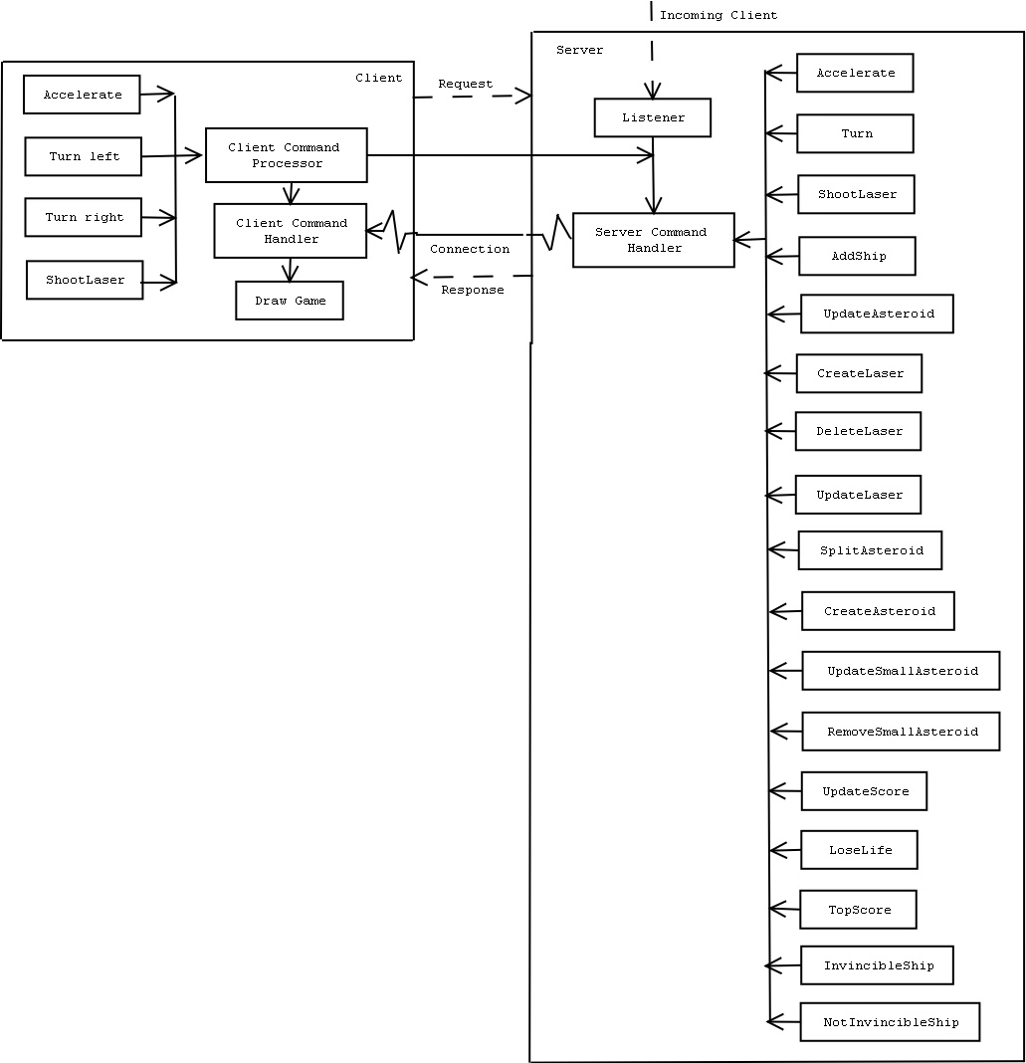
Asteroids component overview 1
A diagram illustrating the main components and the associated functional operations
Chapter | Software Design
4 | Software Design

4.1 Objectives
To produce a design document that describes how the system will be built from the implementation orientated components

4.2 Object Modeling
The Object Model describes the data aspects of the objects within the system and their associations.
4.2.1 Object Classes
- Deriving a list of object classes by examining the problem description.
  - Asteroid
  - Ship
  - Laser
  - Position
  - Velocity
  - Client Command Handler
  - Server Command Handler
  - Connection
  - Listener
  - Top Score
  - Address
  - User
  - Client Command Dispatcher
  - Server Command Dispatcher
  - Server

4.2.2 Data Dictionary
Modeling Entity | Description
Asteroid | An asteroid is a model of a real life asteroid. It will move be displayed on the gaming area, moving at a random velocity in the x and y direction.
Ship | A ship is what the user will control, moving the ship around the game area
Laser | A laser is the ship’s weapon, a single pulse will be fired traveling in the direction the ship is facing
Position | An asteroid, a ship and a laser will all have a position, this position includes an x co-ordinate, a y co-ordinate and an angle
Velocity | An asteroid, a ship and a laser will all have a velocity; this velocity includes an x co-ordinate and a y co-ordinate.
Client Command  Handler | A client command handler handles all the servers requests
Server Command  Handler | A server command handler handles all the clients requests
Connection | This is the message construct through which the client and server communicate
Listener | Listens for incoming connections to the server
Top Score | Stores the current top score
Address | Stores the IP address
User | A User of the system
Client Command  Dispatcher | Used by client to dispatch commands
Server Command  Dispatcher | Used by server to dispatch commands
Server | The main component of the server side
Client Key Listener | The component that listens to users key presses

4.2.3 Identify relations between objects
- Identify dependencies between classes.
Association | Server has a listener
Multiplicity | one-to-one
Description | A server has a listener, a listener can only belong to one server

Association | Server has an address
Multiplicity | one-to-one
Description | A server can have a single address, an address is only associated to one server at a time

Association | Server has a server command handler
Multiplicity | one-to-one
Description | A server has a server command handler, a server command handler is only associated to one server at a time

Association | Server has connections
Multiplicity | one-to-many
Description | A server may have more than one connection, but a user cannot have more than one connection.

Association | Server has a top score
Multiplicity | one-to-one
Description | A server has only one top score, and vice verse.

Association | Server has users
Multiplicity | one-to-many
Description | A server may have more than one user, but a user cannot have more than one connection to a server.

Association | Server has a server command dispatcher
Multiplicity | one-to-one
Description | A server can only have one server command dispatcher, and a server command dispatcher can only belong to one server

Association | Server has multiple asteroids
Multiplicity | one-to-many
Description | A server can have multiple asteroids, but asteroids can only belong to one server

Association | Listener accepts users
Multiplicity | one-to-many
Description | A listener may accept more than one user, but an user cannot be accepted by more then one listener

Association | User has a ship
Multiplicity | one-to-one
Description | A user can have one ship, and a ship can only belong to one user

Association | Ship has multiple lasers
Multiplicity | one-to-many
Description | A ship has more than one laser, but a laser cannot belong to more than one ship

Association | Ship / Laser / Asteroid have a position
Multiplicity | one-to-one
Description | One object can only have one position, a position can only belong to one object

Association | Ship / Laser / Asteroid have a velocity
Multiplicity | one-to-one
Description | One object can only have one velocity, a velocity can only belong to one object

Association | User has a client command handler
Multiplicity | one-to-one
Description | A user has a client command handler and a client command handler belongs to one user

Association | User has a client command dispatcher
Multiplicity | one-to-one
Description | A user has a client command dispatcher and a client command dispatcher belongs to one user

Association | User has a connection
Multiplicity | one-to-one
Description | A user has a single connection, a connection only has one user.

- Using the above object definitions here is the initial object schema:
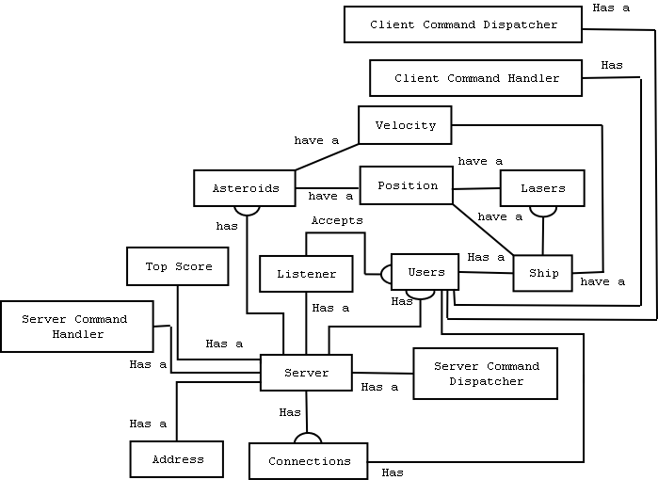
4.2.4 Define attributes of objects
Identifying all attributes of each object:
- Asteroid
  - Small asteroid
  - Active
  - Position
  - Velocity

- Ship
  - Invincible
  - Active
  - Position
  - Velocity

- Laser
  - User
  - Laser number
  - Position
  - Velocity
- Position
  - X co-ordinate
  - Y co-ordinate
  - Angle

- Velocity
  - Speed in x direction
  - Speed in y direction

- Client Command Handler
  - User

- Server Command Handler
  - User

- Connection
  - User

- Listener
  - Address

- Address
  - Host address
  - Port Number

- Top Score
  - Top score value
  - User number

- User
  - User Number
  - Connection
  - Score
  - Number of lives

- Client Command Dispatcher
- User

- Server Command Dispatcher
  - User

- Server
  - Address
  - Listener

4.3 Defining communication channel between client/server
A communication channel between the client and server will have to be defined. That is what is sent between the client and server.

An integer is sent from the client to the server (and vice versa), the client or the server then will react to what command they receive.

Commands:
Command Name | Command Id
Move | 1
Turn | 2
Shoot Laser | 3
Add Ship | 4
Move Asteroid | 5
Update Asteroid | 6
Update laser | 7
Create laser | 8
Delete laser | 9
Split asteroid | 10
Create asteroids | 11
Update small asteroid | 12
Initialise | 14
Remove small asteroid | 15
Refresh | 16
Add asteroid | 17
Add small asteroid | 18
Remove ship | 19
Game over | 20
Make ship invincible | 21
Make ship not invincible | 22
Update score | 23
Lose live | 24
Suspend ship | 25
Top score | 26
New game | 27
Wake ship | 28
live | 29

4.4 Modeling Position and Velocity Data Types
4.4.1 Position
Each ship on the client and server side will contain:
- X co-ordinate
- Y co-ordinate
- Angle (Degrees)
The following functions will be provided:
- Set Position – Sets the x, y co-ordinates and the angle
- Get Angle – Returns the angle
- Increase Angle – Increase the angle by some delta value
- Increase X
- Increase Y

4.4.2 Velocity
Each ship on the client and server side will contain:
- X co-ordinate
- Y co-ordinate
The following functions will be provided:
- Increase X
- Increase Y

4.5 Modeling Game Objects
4.5.1 Asteroids
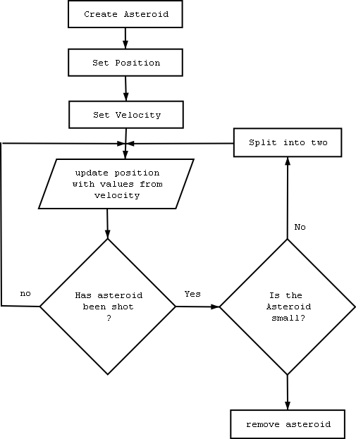
4.5.1.1 Defining an Asteroid
When an asteroid is created it will hold the following attributes:
- A random Position
- A random Velocity (A smaller asteroid has a greater velocity than a bigger asteroid)
- A basic shape
- A sprite

An asteroid will be able to apply the following operations:
- Render the shape
- Move asteroid
- Collision detection

4.5.2 Ship
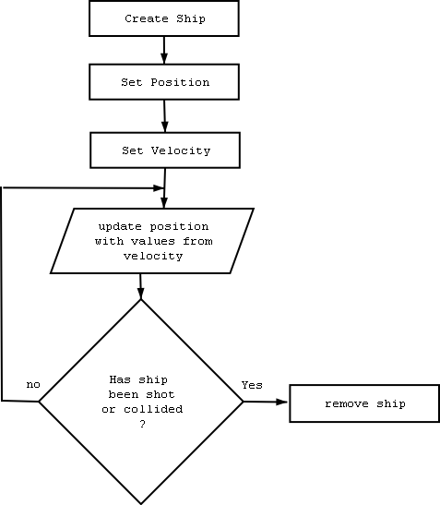
4.5.2.1 Defining a Ship
When a laser is created it will hold the following attributes:
- invincible
- position
- velocity
- shape
- sprite

An asteroid will be able to apply the following operations:
- Render the shape
- Move asteroid
- Collision detection

4.5.3 Laser
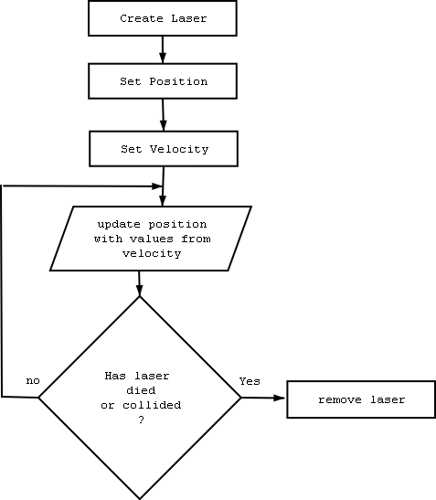
4.5.3.1 Defining a Laser
When a laser is created it will hold the following attributes:
- laser number
- user number
- position
- velocity
- shape
- sprite

An asteroid will be able to apply the following operations:
- Render the shape
- Move asteroid
- Collision detection

4.5.4 Modeling Game Object using Inheritance

Using a top down approach identifying classes into specific superclass

- The classes Asteroid, laser and ship can be refined using inheritance. The three objects share the following common attributes:
  - Position
  - Velocity
  - Movement
  - Collisions
  - Shape
  - Sprite
- The common abstract class is called GameObject

4.5.5 Modeling Position and Velocity using Inheritance
Analysing the section 4.2.4 (Define attributes of objects), it is clear that position and velocity share common attributes.
- The two objects share the following common attributes
  - X value
  - Y value
- The common abstract class is called Mechanics

4.6 Modeling Client/Server Functions
This section describes the interface between components and objects within the system, including management aspects of the system that change over time.

4.6.1 Normal scenarios

These scenarios are those sequences that are able to produce the preferred output.

4.6.1.1 Server Operations

The functions listed below are the server side functions.

- ClientCommandHandler
Function Name | processCommand
Description | This function processes a command.
Input | commandId – The command received
Output | The associated command executed
Other | Synchronization is needed – to avoid client processing more than one command at a time
Error Handling | Not needed, as the commands are defined
Function server::processCommand ( commandId : Integer) returns void
begin
if commandId is move
Process Move Command
else if commandId is turn
Process Turn Command
else if commandId is shoot
Process shoot laser Command

end processCommand

Function Name | processMoveCommand
Description | This function processes a move command.
Input | None
Output | The Ship being accelerated
Other | Synchronization is needed – to avoid client processing more than one move command at a time
Error Handling | None
function server::processMoveCommand returns void
begin
accelerate the ship
end processCommand

Function Name | processTurnCommand
Description | This function processes a turn command.
Input | None
Output | The Ship being turned
Other | Synchronization is needed – to avoid client processing more than one move command at a time
Error Handling | None
function server::processTurnCommand returns void
begin
Get input stream
Read in turn request
If the turn request is a turn right request
Turn the ship to the right
Else if the turn request is a turn left request
Turn the ship to the left
end processTurnCommand

Function Name | processShootLaserCommand
Description | This function processes a shoot command.
Input | None
Output | A laser being created assigned to the ship
Other | Synchronization is needed – to avoid client processing more than one move command at a time
Error Handling | None
function server::processTurnCommand returns void
begin
if the ship is active
Add a laser assigned to the ship
end processTurnCommand

- Connection
Function Name | Read
Description | This function reads in an integer
Input | None
Output | Integer being passed onto process command function
Other | none
Error Handling | Try to read in an integer, if failed just close the connection
function server::read returns void
begin
while not terminated
read in integer
pass integer to process command
end while
end processTurnCommand

Function Name | Write
Description | This function writes an integer
Input | Integer to be written
Output | None
Other | None
Error Handling | Try to write to the output stream, if fails then terminate.
function server::read returns void
begin
if not terminated
write integer
end if
end processTurnCommand

- CommandDispatcher
Function Name | sendMoveCommand
Description | This function issues a move command.
Input | None
Output | The client receiving an x and y co-ordinate
Other | Synchronization is needed – to avoid client processing more than one command at a time
Error Handling | None
function server::sendMoveCommand (void) returns void
begin
Send to all users a move command
Send to all users the user number
Send to all users the x co-ordinate
Send to all users the y co-ordinate
end sendMoveCommand

Function Name | sendTurnCommand
Description | This function issues a turn command.
Input | none
Output | Clients receiving the new angle for a ship
Other | Synchronization is needed – to avoid client processing more than one command at a time
Error Handling | None
function server::sendTurnCommand (void) returns void
begin
Send to all users a turn command
Send to all users the user number
Send to all users the angle
end sendTurnCommand

Function Name | sendAddShipCommand
Description | This function issues an add ship command.
Input | None
Output | Clients adding a new ship to the game
Other | Synchronization is needed – to avoid client processing more than one command at a time
Error Handling | None
function server::sendAddShipCommand (void) returns void
begin
Send to all users an add ship command
Send to all users the user number
end sendAddShipCommand

Function Name | sendMoveAsteroidCommand
Description | This function issues a move asteroid command.
Input | none
Output | Clients moving an asteroid
Other | Synchronization is needed – to avoid client processing more than one command at a time
Error Handling | None
function server:: sendMoveAsteroidCommand (void) returns void
begin
Send to all users the asteroid number
Send to all users the x co-ordinate
Send to all users the y co-ordinate
end sendAddShipCommand

Function Name | sendCreateLaserCommand
Description | This function issues a create laser command.
Input | None
Output | Clients creating a laser
Other | Synchronization is needed – to avoid client processing more than one command at a time
Error Handling | None
function server:: sendCreateLaserCommand (void) returns void
begin
Send to all users a move asteroid command
Send to all users the x co-ordinate
Send to all users the y co-ordinate
Send to all users the angle
Send to all users the laser number
Send to all users the user number
end sendCreateLaserCommand

Function Name | sendDeleteLaserCommand
Description | This function issues a delete laser command
Input | none
Output | Clients delete a laser
Other | Synchronization is needed – to avoid client processing more than one command at a time
Error Handling | None
function server:: sendDeleteLaserCommand (void) returns void
begin
Send to all users a delete laser command
Send to all users the user number
Send to all users the laser number
end sendDeleteLaserCommand

Function Name | sendLaserCommand
Description | This function issues a move laser command.
Input | none
Output | Clients updating the laser’s position
Other | Synchronization is needed – to avoid client processing more than one command at a time
Error Handling | None
function server:: sendLaserCommand (void) returns void
begin
Send to all users the move laser command
Send to all users the user number
Send to all users the laser number
Send to all users the x co-ordinate
Send to all users the y co-ordinate
end sendLaserCommand

Function Name | sendSplitAsteroidCommand
Description | This function issues a split asteroid command.
Input | none
Output | Clients splitting an asteroid
Other | Synchronization is needed – to avoid client processing more than one command at a time
Error Handling | Non
function server:: sendSplitAsteroidCommand (void) returns void
begin
Send to all users the split asteroid command
Send to all users the asteroid number
end sendSplitAsteroidCommand

Function Name | sendUpdateSmallAsteroidCommand
Description | This function issues an update small asteroid command.
Input | none
Output | Clients updating a small asteroid position
Other | Synchronization is needed – to avoid client processing more than one command at a time
Error Handling | None
function server:: sendUpdateSmallAsteroidCommand (void) returns void
begin
Send to all users the update small asteroid command
Send to all users the asteroid number
Send to all users the x co-ordinate
Send to all users the y co-ordinate
end sendUpdateSmallAsteroidCommand

Function Name | sendRemoveSmallAsteroidsCommand
Description | This function issues a remove small asteroid command.
Input | none
Output | Clients removing a small asteroid
Other | Synchronization is needed – to avoid client processing more than one command at a time
Error Handling | None
function server:: sendRemoveSmallAsteroidsCommand (void) returns void
begin
Send to all users the remove small asteroid command
Send to all users the asteroid number
end sendRemoveSmallAsteroidCommand

Function Name | sendUpdateSmallAsteroidCommand
Description | This function issues an update small asteroid command.
Input | none
Output | Clients updating the position of small asteroids
Other | Synchronization is needed – to avoid client processing more than one command at a time
Error Handling | None
function server:: sendUpdateSmallAsteroidCommand (void) returns void
begin
Send to all users the update small asteroid command
Send to all users the asteroid number
Send to all users the x co-ordinate
Send to all users the y co-ordinate
end sendUpdateSmallAsteroidCommand

Function Name | sendAddAsteroidCommand
Description | This function issues an add asteroid command.
Input | none
Output | Clients adding an asteroid to the game
Other | Synchronization is needed – to avoid client processing more than one command at a time
Error Handling | None
function server:: sendAddAsteroidCommand (void) returns void
begin
Send to all users the add asteroid command
Send to all users the asteroid number
end sendUpdateSmallAsteroidCommand

Function Name | sendAddSmallAsteroidCommand
Description | This function issues an add small asteroid command.
Input | none
Output | Clients adding a small asteroid
Other | Synchronization is needed – to avoid client processing more than one command at a time
Error Handling | None
function server:: sendAddSmallAsteroidCommand (void) returns void
begin
Send to all users the add small asteroid command
Send to all users the asteroid number
Send to all users the x co-ordinate
Send to all users the y co-ordinate
end sendAddSmallAsteroidCommand

Function Name | sendRemoveShipCommand
Description | This function issues a remove ship command.
Input | None
Output | A ship being removed from the game
Other | Synchronization is needed – to avoid client processing more than one command at a time
Error Handling | None
function server:: sendRemoveShipCommand (void) returns void
begin
Send to all users the remove ship command
Send to all users the user number
end sendRemoveShipCommand

Function Name | sendMakeShipInvincibleCommand
Description | This function issues a make ship invincible command.
Input | None
Output | Clients make a ship invincible
Other | Synchronization is needed – to avoid client processing more than one command at a time
Error Handling | None
function server:: sendUpdateSmallAsteroidCommand (void) returns void
begin
Send to all users the make ship invincible command
Send to all users the user number
end sendUpdateSmallAsteroidCommand

Function Name | sendMakeShipNotInvincibleCommand
Description | This function issues a make ship not invincible command.
Input | None
Output | Clients make a ship not invincible
Other | Synchronization is needed – to avoid client processing more than one command at a time
Error Handling | None
function server:: sendMakeShipNotInvincibleCommand (void) returns void
begin
Send to all users the make ship not invincible
Send to all users the user number
end sendMakeShipNotInvincibleCommand

Function Name | sendUpdateScoreCommand
Description | This function issues an update score command.
Input | None
Output | The client’s score being updated
Other | Synchronization is needed – to avoid client processing more than one command at a time
Error Handling | None
function server:: sendUpdateScoreCommand (void) returns void
begin
Send user the update score command
Send points
end sendUpdateScoreCommand

Function Name | sendLoseLiveCommand
Description | This function issues a lose live command.
Input | None
Output | Client reducing their number of lives
Other | Synchronization is needed – to avoid client processing more than one command at a time
Error Handling | None
function server:: sendLoseLiveCommand (void) returns void
begin
send user the lose live command
end sendLoseLiveCommand

Function Name | sendTopScoreCommand
Description | This function issues a top score command.
Input | none
Output | Clients updating the top score
Other | Synchronization is needed – to avoid client processing more than one command at a time
Error Handling | None
function server:: sendTopScoreCommand (void) returns void
begin
Send to all users the top score command
Send to all users the user number
Send to all users the top score
end sendTopScoreCommand

During the course of the game the server will do numerous calculations, such as, send ship/laser/asteroid positions, check for collisions, update scores and update number of lives.

Here is a flowchart showing how the server will perform these operations. (NB, the diagram was divided into two parts to make it more legible)
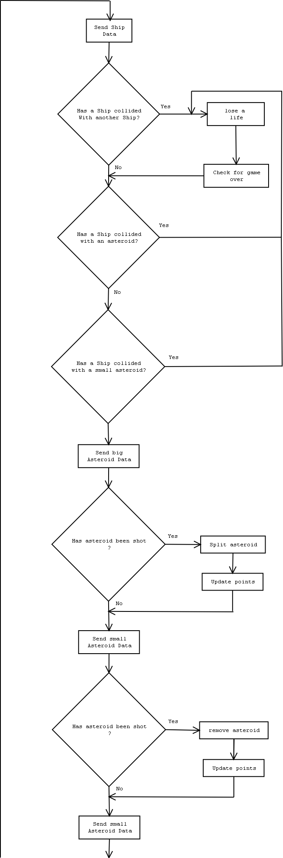
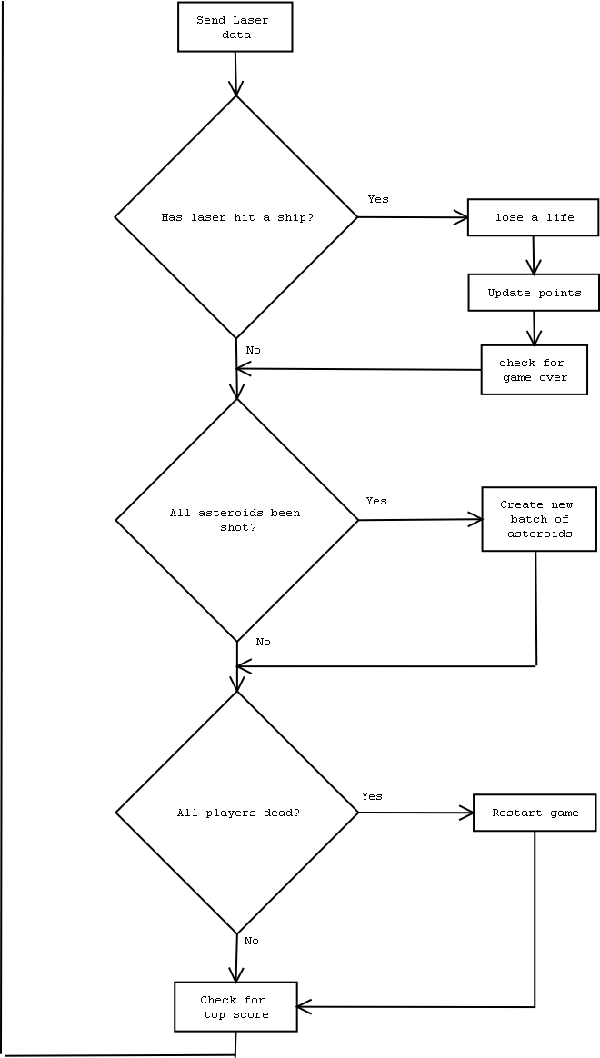

4.6.1.2 Client Operations

The Client has to react to commands sent from the Server. The client can only send three commands:

- ClientCommandProcessor

Function Name | sendCommand
Description | This function sends a command from the client to the server
Input | commandId – The command to be sent
Output | The commandId is sent to the server
Other | Synchronization is needed – To avoid client sending multiple commands at the same time
Error Handling | None
function client::sendCommand ( commandId : Integer) returns void
begin
write commandId to connection
end sendCommand

- ClientCommandHandler

Function Name | processCommand
Description | This function processes a command.
Input | commandId – The command received
Output | The associated command executed
Other | Synchronization is needed – to avoid client processing more than one command at a time
Error Handling | If commandId not found, then just ignore the command and print a suitable print statement
function client::processCommand ( commandId : Integer) returns void
begin
if commandId is move
Process Move Command
else if commandId is turn
Process Turn Command
else if commandId is add ship
Process add ship command
else if commandId is update asteroid
Process move asteroid command
else if commandId is update laser
Process laser command
else if commandId is create laser
Process create laser command
else if commandId is delete laser
Process delete laser command
else if commandId is split asteroid
Process split asteroid command
else if commandId is create asteroid
Process create asteroid command
else if commandId is update small asteroid
Process update small asteroid command
else if commandId is remove small asteroid
Process remove small asteroid command
else if commandId is refresh
Process refresh command
else if commandId is add asteroid
Process add asteroid
else if commandId is add small asteroid
Process add small asteroid command
else if commandId is remove ship
Process remove ship command
else if commandId is make ship invincible
Process make ship invincible command
else if commandId is make ship not invincible
Process make ship not invincible command
else if commandId is update score
Process update score command
else if commandId is lose live
Process lose live command
else if commandId is top score
Process top score command
else if commandId is life
Process live command
end processCommand

Function Name | processMoveCommand
Description | This function processes a move command.
Input | none
Output | The ship being moved
Other | Synchronization is needed – to avoid client processing more than one command at a time
Error Handling | If reading in integers fails, print a suitable print statement
function client::processMoveCommand (void) returns void
begin
Get input stream
Read in user number
Read in x co-ordinate
Read in y co-ordinate
Move ship assigned to user number to the new position
end processMoveCommand

Function Name | ProcessTurnCommand
Description | This function processes a turn command.
Input | none
Output | The ship being turned
Other | Synchronization is needed – to avoid client processing more than one command at a time
Error Handling | If reading in integers fails, print a suitable print statement
function client::processTurnCommand (void) returns void
begin
Get input stream
Read in user number
Read in an angle

Turn ship assigned to user number to the new position
end processTurnCommand

Function Name | processAddShipCommand
Description | This function processes an add ship command.
Input | none
Output | A new ship added to the game
Other | Synchronization is needed – to avoid client processing more than one command at a time
Error Handling | If reading in integers fails, print a suitable print statement
function client::processAddShipCommand (void) returns void
begin
Get input stream
Read in user number
Add ship assigned to user number
end processAddShipCommand

Function Name | processMoveAsteroidCommand
Description | This function processes a move asteroid command.
Input | none
Output | An Asteroid’s position being updated
Other | Synchronization is needed – to avoid client processing more than one command at a time
Error Handling | If reading in integers fails, print a suitable print statement
function client:: processMoveAsteroidCommand (void) returns void
begin
Get input stream
Read in asteroid number
Read in x co-ordinate
Read in y co-ordinate
Add ship assigned to user number
end processMoveShipCommand

Function Name | processCreateLaserCommand
Description | This function processes a create laser command.
Input | none
Output | A laser being created
Other | Synchronization is needed – to avoid client processing more than one command at a time
Error Handling | If reading in integers fails, print a suitable print statement
function client:: processCreateLaserCommand (void) returns void
begin
Get input stream
Read in x co-ordinate
Read in y co-ordinate
Read in angle
Read in laser number
Read in user number
create a laser using the data read in
end processCreateLaserCommand

Function Name | processDeleteLaserCommand
Description | This function processes a delete laser command.
Input | none
Output | A laser being deleted
Other | Synchronization is needed – to avoid client processing more than one command at a time
Error Handling | If reading in integers fails, print a suitable print statement
function client:: processDeleteLaserCommand (void) returns void
begin
Get input stream
Read in user number
Read in laser number
delete the appropriate laser
end processDeleteLaserCommand

Function Name | processLaserCommand
Description | This function processes a move laser command.
Input | none
Output | A laser’s position being updated
Other | Synchronization is needed – to avoid client processing more than one command at a time
Error Handling | If reading in integers fails, print a suitable print statement
function client:: processLaserCommand (void) returns void
begin
Get input stream
Read in user number
Read in laser number
Read in x co-ordinate
Read in y co-ordinate
move the appropriate laser
end processLaserCommand

Function Name | processSplitAsteroidCommand
Description | This function processes a split asteroid command.
Input | None
Output | An asteroid being split into two
Other | Synchronization is needed – to avoid client processing more than one command at a time
Error Handling | If reading in integers fails, print a suitable print statement
function client:: processSplitAsteroidCommand (void) returns void
begin
Get input stream
Read in asteroid number
Split the asteroid into two
end processSplitAsteroidCommand

Function Name | processUpdateSmallAsteroidCommand
Description | This function processes an update small asteroid command.
Input | none
Output | A small asteroid’s position being updated
Other | Synchronization is needed – to avoid client processing more than one command at a time
Error Handling | If reading in integers fails, print a suitable print statement
function client:: processUpdateSmallAsteroidCommand (void) returns void
begin
Get input stream
Read in asteroid number
Read in x co-ordinate
Read in y co-ordinate
create a laser using the data read in
end processUpdateSmallAsteroidCommand

Function Name | processRemoveSmallAsteroidsCommand
Description | This function processes a remove small asteroid command.
Input | None
Output | A small asteroid being removed from the game
Other | Synchronization is needed – to avoid client processing more than one command at a time
Error Handling | If reading in integers fails, print a suitable print statement
function client:: processRemoveSmallAsteroidsCommand (void) returns void
begin
Get input stream
Read in asteroid number
remove the asteroid assigned to the asteroid number
end processRemoveSmallAsteroidCommand

Function Name | processUpdateSmallAsteroidCommand
Description | This function processes an update small asteroid command.
Input | None
Output | A small asteroid’s position being updated
Other | Synchronization is needed – to avoid client processing more than one command at a time
Error Handling | If reading in integers fails, print a suitable print statement
function client:: processUpdateSmallAsteroidCommand (void) returns void
begin
Get input stream
Read in asteroid number
Read in x co-ordinate
Read in y co-ordinate
create a laser using the data read in
end processUpdateSmallAsteroidCommand

Function Name | processAddAsteroidCommand
Description | This function processes an add asteroid command.
Input | None
Output | An asteroid being added to the game
Other | Synchronization is needed – to avoid client processing more than one command at a time
Error Handling | If reading in integers fails, print a suitable print statement
function client:: processAddAsteroidCommand (void) returns void
begin
Get input stream
Read in asteroid number
Add an asteroid using the asteroid number
end processUpdateSmallAsteroidCommand

Function Name | processAddSmallAsteroidCommand
Description | This function processes an add small asteroid command.
Input | none
Output | A small asteroid being added
Other | Synchronization is needed – to avoid client processing more than one command at a time
Error Handling | If reading in integers fails, print a suitable print statement
function client:: processAddSmallAsteroidCommand (void) returns void
begin
Get input stream
Read in asteroid number
Read in x co-ordinate
Read in y co-ordinate
create a small asteroid using the data read in
end processAddSmallAsteroidCommand

Function Name | processRemoveShipCommand
Description | This function processes a remove ship command.
Input | none
Output | A ship being removed from the game
Other | Synchronization is needed – to avoid client processing more than one command at a time
Error Handling | If reading in integers fails, print a suitable print statement
function client:: processRemoveShipCommand (void) returns void
begin
Get input stream
Read in user number
Remove a ship according to the user number
end processRemoveShipCommand

Function Name | processMakeShipInvincibleCommand
Description | This function processes a make ship invincible command.
Input | None
Output | A ship being made invincible
Other | Synchronization is needed – to avoid client processing more than one command at a time
Error Handling | If reading in integers fails, print a suitable print statement
function client:: processUpdateSmallAsteroidCommand (void) returns void
begin
Get input stream
Read in user number
Make the ship invincible according to the user number
end processUpdateSmallAsteroidCommand

Function Name | processMakeShipNotInvincibleCommand
Description | This function processes a make ship not invincible command.
Input | None
Output | A ship being made not invincible
Other | Synchronization is needed – to avoid client processing more than one command at a time
Error Handling | If reading in integers fails, print a suitable print statement
function client:: processMakeShipNotInvincibleCommand (void) returns void
begin
Get input stream
Read in user number
Make the ship not invincible according to the user number
end processMakeShipNotInvincibleCommand

Function Name | processUpdateScoreCommand
Description | This function processes an update score command.
Input | None
Output | The client’s score being updated
Other | Synchronization is needed – to avoid client processing more than one command at a time
Error Handling | If reading in integers fails, print a suitable print statement
function client:: processUpdateScoreCommand (void) returns void
begin
Get input stream
Read in points
add points to the current number of points
end processUpdateScoreCommand

Function Name | processLoseLiveCommand
Description | This function processes a lose live command.
Input | None
Output | Number of lives being reduced by one
Other | Synchronization is needed – to avoid client processing more than one command at a time
Error Handling | If reading in integers fails, print a suitable print statement
function client:: processLoseLiveCommand (void) returns void
begin
Deduct one live from number of lives remaining
end processLoseLiveCommand

Function Name | processTopScoreCommand
Description | This function processes a top score command.
Input | None
Output | The top score being updated
Other | Synchronization is needed – to avoid client processing more than one command at a time
Error Handling | If reading in integers fails, print a suitable print statement
function client:: processTopScoreCommand (void) returns void
begin
Get input stream
Read in user number
Read in top score
Set the top score and who achieved it accordinly
end processTopScoreCommand

4.6.3 Client/Server synchronization

There is a need for the client side and server side to be in synchronization. Consider the following basic communication between the client/server.
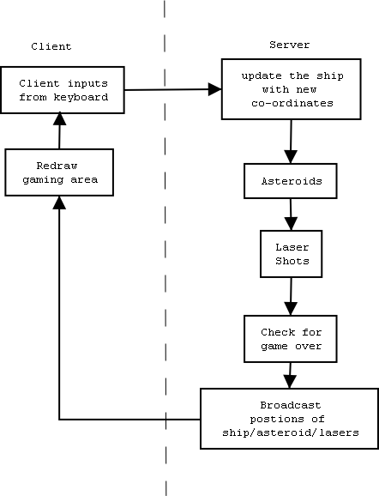
If the client is redrawing the gaming area, and the server sends a remove laser command, the laser is removed from the game and the client is trying to draw it, an error will occur. So we must force the client to redraw the game. The server will send a refresh command to the client.

4.6.4 CommandHandler Interface

The Server Command Handler and the Client Command Handler can both be implemented using an interface.
An interface will be created with the function processCommand(Integer: CommandId)

4.6.5 Detecting Collisions
To detect a collision a check will be made to see if two polygons intersect each other.

Function Name | isColliding
Description | This function tests whether two polygons intersect each other. The polygon passed in is tested with the current sprite of the game object
Input | Polygon – polygon to check if collision has occurred
Output | A Boolean value to indicate the success of the operation or otherwise
Other | Synchronization is needed – to avoid processing more than one collision at a time
Error Handling | None
function server:: isColliding (Polygon : polgyon) returns boolean
begin
for each point of the polygon
if the sprite contain the current point of the polygon
return true
for each point of the sprite
if the polygon contains the current point of the sprite
return true
return false
end isColliding

4.6.6 Rendering a sprite
Each game object sprite as it is moved needs to be rendered to that the client and server knows of its position.

Function Name | Render
Description | This function advances the points of the polygon to its new position
Input | None
Output | None
Other | None
Error Handling | None
function server:: render(void) returns void
begin
create a new sprite
get the current angle in radians
for each point of the polygon
Calculate position angle in radians
Calculate the length
New x co-ordinate : = currentX + (length * Cos(currentAngle + positionAngle))
New y co-ordinate : = currentY - (length * Sin(currentAngle + positionAngle))
Add new co-ordinate to the sprite
end render

4.7 Managing Game Objects and Users
There needs to be a clear mechanism that enables both the client and server to manage game objects and Users successfully.

4.7.1 Defining a User Manager
The user manager will contain:
- A list of users. (Size of list depends on the maximum users allowed)
The user manager will supply the following operations:
- Create User – Adds a user to the list of users
- Remove User – Removes a user from the list of users
- Write To All Users – writes data to every user on the list of users

4.7.2 Defining a ship manager
Each ship on the client and server side will contain:
- A list of ships (Size of list depends on the maximum number of clients)

The server side ship manager will supply the following operations:
- Add ship – Adds a ship to the list of ships
- Remove ship – Removes a ship from the list of ships

The client side ship manager will supply the following operations:
- Add Ship (See server ship manager)
- Remove Ship (See server ship manager)
- Move Ship - Sets position of ship
- Turn Ship - Sets angle of ship
- Get Colour - Returns colour of the ship
- Get Position - Returns the position of the ship

4.7.2 Defining an Asteroid manager
Each ship on the client and server side will contain:
- A list of big asteroids
- A list of small asteroids

The client and server asteroid manager will supply the following operations:
- Add all asteroids – Adds an asteroid to the list of big asteroids
- Remove asteroid – Removes an asteroid from the list of big asteroid
- Move asteroid – Sets the position of an asteroid on the list of big asteroids
- Remove small asteroid - Remove an asteroid from the list of small asteroids
- Split asteroid – Removes a big asteroid and replaces it by two smaller asteroids
4.7.2 Defining a Laser manager
Each laser on the client and server side will contain:
- A 2d list of type lasers.
  - Size will be maximum clients * maximum shots

The client and server laser manager will supply the following operations:
- Add laser – adds a laser to the list
- Remove laser – Removes a laser

The client needs one more operation
- Move laser – Sets the position of a laser

4.8 Constant Definitions
There are numerous constants that need to be defined. Below is a table showing these constants and their values.

Constant | Constant value
Acceleration | 1
Angle to turn ship | 15
Speed Limit | 15
Client Width | 500
Client Height | 500
Move Forward | 2
Turn Left | 3
Turn Right | 4
Min rock sides | 8
Max rock sides | 12
Min rock size | 20
Max rock size | 40
Min rock speed | 2
Max rock speed | 12
Max shots | 5
Number of lives | 3
Points big asteroid | 30
Points small asteroid | 40
Points ship | 100
Max asteroids | 5
Big asteroid velocity x | 3
Big asteroid velocity y | 3
Small asteroid velocity x | 6
Small asteroid velocity y | 6
Laser velocity x | 18
Laser velocity y | 18

4.9 Client side connection
Below is a flowchart below showing the operations performed by the client upon loading.
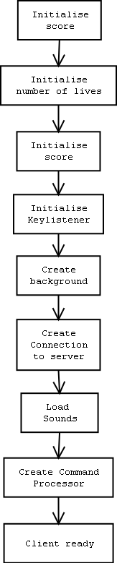

4.9.1 Drawing game objects

Function Name | Draw
Description | This function draws the objects on the clients
Input | None
Output | Shapes being drawn
Other | None
Error Handling | None
function client:: draw(void) returns void
begin
paint the background black
draw the stars
for each ship in the client ship manager
begin
if ship is active
set the colour for the ship
if the ship is invincible then make ship flash
draw polygon for the ship
end
end
for each asteroid in the client asteroid manager
begin
set the asteroid colour to white
draw the polygon for the asteroid
end
end
for each small asteroid in the client asteroid manager
begin
set the small asteroid colour to white
draw the polygon for the small asteroid
end
end
for each laser in the client laser manager
begin
set the colour to the colour of the ship
draw the polygon for the laser
end
end
end draw

Below is a flowchart showing the events of what the client will see when they hit a key. (See User Interface Design for more detail)

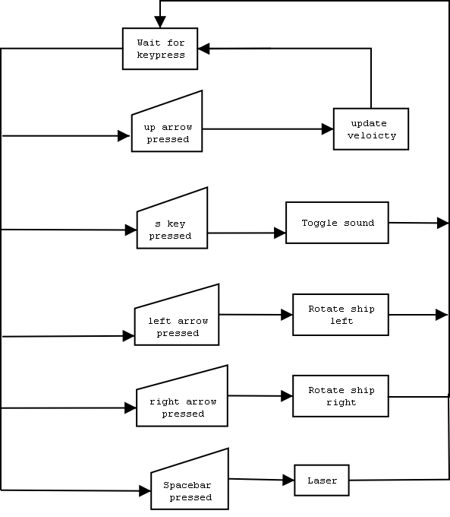

4.10 Game events
There are numerous game events that can occur during the course of the game.
Event | Loses a life
Outcome | - Total number of lives deducted by one.  - Check for game over  - make ship invincible  - Re-insert ship onto gaming area with a random position
Other | Client will see a flashing message saying “You lost a life”

Event | Game over
Outcome | - Suspend ship from game  - Client cannot move their ship or shoot laser
Other | Client will see a message saying “Game Over”

Event | All user’s game is over
Outcome | - Server will calculate who has won the game by who has the most points  - Client displays the winner
Other | None

Event | Big asteroid shot
Outcome | - Asteroid is split into two smaller asteroids  - These two smaller asteroids have a greater velocity than the big asteroid
Other | Client gets 30 points for shooting a big asteroid

Event | Small asteroid shot
Outcome | - Asteroid is removed from the gaming area
Other | Client gets 50 points for shooting a small asteroid

Event | Ship shot by another ship
Outcome | - Deduct a life from the ship that was shot  - Check for game over for the ship that was shot
Other | Client gets 100 points for shooting another ship

Event | Ship collides with another ship
Outcome | - Deduct a life from each ship  - Check for game over on both ships
Other | None

Event | Ship collides with a big or small asteroid
Outcome | - Deduct a life from the ship  - Check for game over
Other | None

4.11 Error Handling
4.11.1 Server-side Error Handling

There are certain scenarios that produce errors they include

Processing an unknown command
The command is just ignore by the server command handler

Trying to add a new user when the server is full
User Manager:
If there is no room to add a new user then
- Close the socket connection
- Send command to client saying server is full
- Throw a new Connection Limit Exception (See section 4.11.3)

Listener:
Catch Connection Limit Exception, then
- Close socket

Reading in integer from connection
If an error occurs during reading in an integer from the socket then
- Close socket
- Remove User
- Display closing message

4.11.2 Client-side Error Handling

Client connecting to server
The client must make sure it is connected to the server before continuing on.
- Check that the client is connected by waiting for go ahead flag from server

Reading in integer from connection
If an error occurs during reading in an integer from the socket then
- Close socket
- Remove User
- Display closing message

Processing an unknown command
The command is just ignore by the client command handler

Processing any command
If an error occurs while reading in an integer, then
- Catch error
- Print suitable statement
4.11.3 Defining Connection Limit Exception

ConnectionLimitException class will inherit the java.io.Exception class.
ConnectionLimitException is thrown when there are no more connections available on the server.

4.12 UML
See appendix B for a UML diagram of the system.

4.13 Event Trace Diagrams
4.13.1 User key press example (key 38)

See page 72.

4.13.2 User Connecting to Server

See page 73

Chapter | User Interface Design
5 | User Interface Design

5.1 Objectives
To produce a document that clearly and precisely defines the design elements of the user interface. This should show clearly how the systems user interface components are incorporated.

5.2 Playing Area
The size of the playing area is a pre-defined area that is 500 pixels x 500 pixels. Below is an image of what the playing area should look like.

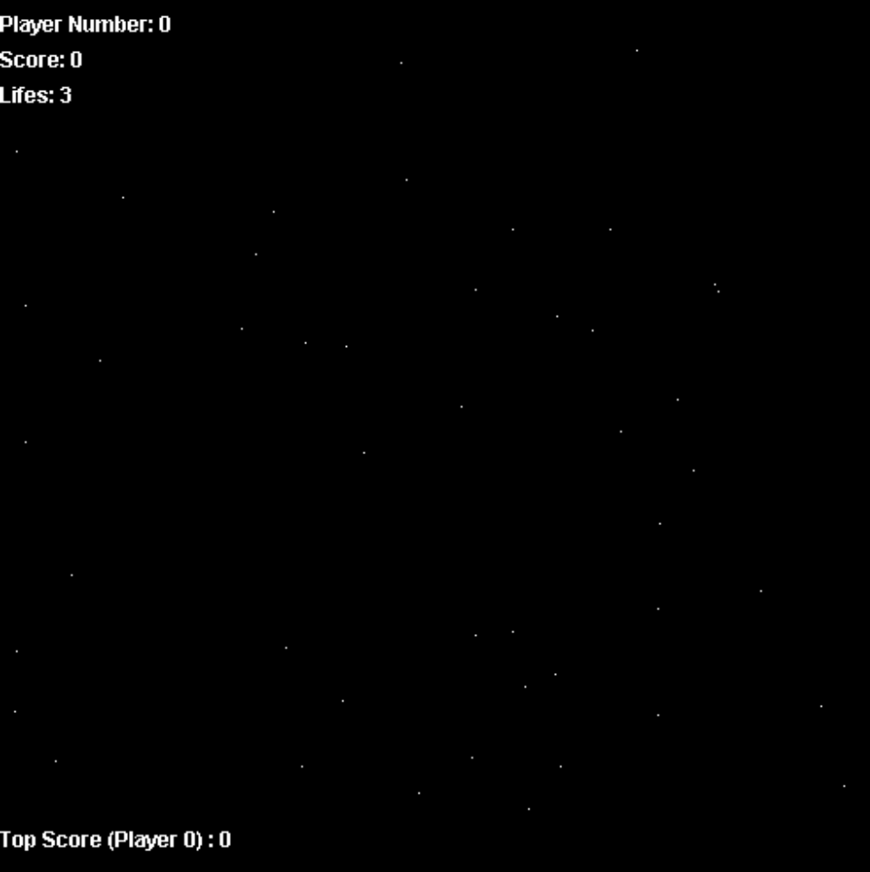

- The stars are random white points scattered around the game area. Each client will be responsible for drawing their own background. This is not a critical aspect, so it doesn’t matter what each client sees the background as.
- On the top left of the screen, the player number, score and number of lives remaining are displayed
- On the bottom left of the screen the top score is displayed along with the player number who achieved the top score.
- The gaming area is where the actual game takes place, the ships, the lasers and the asteroids will all move on this area.

5.3 Asteroids
- An asteroid is made up of random points based around the origin of the asteroid.



- You can see in the diagram above that the points extend from the origin of the asteroid. The lines coming from the centre of the asteroid have a starting length then add a random value (between a defined min and max) to the starting length.
- The origin of the asteroid is defined as:
  - X co-ordinate
  - Y co-ordinate
(Position)
- The asteroids will be coloured white.
- Each client will see a different shaped asteroid, but the shape will be varied by a little amount. What the asteroid looks like is non critical data, the positions of each asteroid is what matters.

5.4 Ships
Below is what the basic shape of the ship.
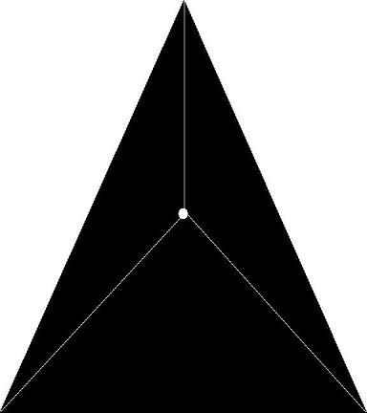

- The white dot is the centre of the ship. The ship will be drawn in relation to this. This is where the position points to.
- When the ship is invincible it will flash, this is so that the user knows that the ship is invincible.
- The laser will originate from the centre of the ship
- When the ship is not invincible it will stay a static colour.
- Each ship will be a different colour. Below is a table listing these colours.

Ship Number | Colour
0 | Blue
1 | Red
2 | Green
3 | Orange

5.5 Lasers
- Lasers will have a rectangular shape.
- They will have the same colour as the ship which from the originated from
- The laser will originate from the centre of the ship.

5.6 Controlling the Ship
The user will input data from the keyboard. The following keys will be available to the user.

Key | Key code | Effect
Up arrow | 38 | Accelerate ship
Left arrow | 37 | Turn ship left
Right arrow | 39 | Turn ship right
Space bar | 32 | Shoot laser
S key | 83 | Toggles sound on and off

5.7 Front-end webpage
This is a user’s “first impressions” of the system, if it is a dull, boring webpage then the potential user may look somewhere else.

A list of design factors that will be put into practice:

- Speed
If it’s a new user to the system then the user will want to take time to go through the help documents, that is, how to control the ship, shoot a laser and any other vital information that a new user would need. However, if the user is an experienced user then they might just want to get into the game without having to scroll through lots of information they already know.

- Time to learn
It is important that the system is easy to use. Asteroids should provide sufficient information that will enable the user to learn the system quickly and efficiently.

The web page will be split up into numerous sections, they include:

- What Asteroids actually is
- How to start the game
- The main objectives of Asteroids
- How to control the ship

5.8 Sounds
Sounds will be generated when a certain action is performed. Below is a list of these actions

Function | Thruster sound.
User Inputs | Up arrow
User Errors | None
Design comments | - Make sure that the sound option is on  - Make sure that the user’s game isn’t over. If it is over then they can’t hear the sound

Function | Shooting sound.
User Inputs | Space bar
User Errors | None
Design comments | - Make sure that the sound option is on  - All user’s will be able to hear each others laser shots

Function | Crash
User Inputs | None
User Errors | None
Design comments | - Make sure that the sound option is on  - All user’s will be able to hear the crash sound  - Crash sound happens when ships hit each other or hit an asteroid

Function | Explosion
User Inputs | None
User Errors | None
Design comments | - Make sure that the sound option is on  - All user’s will be able to hear the explosion  - Explosion sound will be heard when a ship is destroyed

5.9 User Interface Design Evaluation
Overall, the operational interface developed satisfies the user requirements as set out in the Requirements Specification.

The user interface has been designed to the following principles outlined below:
- The system is user friendly and intuitive to use.
- Input mechanisms are constrained to a limited set that are used time after time through out the system.
- Knowledgeable users can go straight to the game without page upon page of information that they already know
- Novice users can learn how to control their ship before entering the game.

Chapter | Implementation
6 | Implementation

6.1 Objectives
Transforming the abstract data types from the Functional Specification, and its operational functions into a working computer program. The end product will be a program source code

6.2 System Integration Strategy
There are numerous methods to implement the system, they include:
- Big-bang integration strategy
  - Every module is coded separately. All modules are integrated together, unit testing is often ignored
- Top-down Integration strategy
  - Modules at the top of the structure are coded and integrated first. Then modules from a lower level are added on
- Bottom-up Integration strategy
  - The lowest level modules are coded, tested and integrated first. Then modules from a higher level are added on forming subsystems

For this system the bottom-up strategy will be used, mainly because the lower level modules will receive more testing than the higher level modules. This is critical because the lower level modules are what the system will be created from.

6.3 Coding Strategy
The programming language used to implement the system will be Java 1.3.1. Code reuse is of vital importance as there is a tight schedule to adhere to. As specified in the Requirements Specification, maintenance is a prime objective of the finished system, hence the importance of splitting up the problem into a series of self contained classes.

The end product of this phase will be the application source code. The source code will be listed in the appendix.

6.4 Convention and Coding standards
6.4.1 Packages
A new java package will be created for each self-contained project or group of related functionality.
In Asteroids case there will be two packages:
- Server – For server related classes
- Client – For Client related classes

6.4.1 Comments
Each method will be commented using the Javadoc standard. For example:

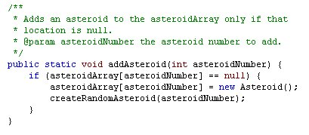
6.4.2 Naming Convention
The names given to methods, functions, variables, classes or any other constructs will be carefully chosen. This will increase readability of the code and hopefully prevent programming errors.

6.5 Javadoc
See floppy disk provided with documentation for Javadoc html files. (Not enough room to include printouts of the Javadoc HTML files within this documentation).

6.6 Installable Build
An asteroids jar file must be created; this will include the package structure and all the class files. A batch file will be created to execute the server program, a readme file will be provided to provide the end user any last minute details not provided within the User guide and/or this document.
To create an installable build, NSIS is used (available for free download at http://www.nullsoft.com/free/nsis/). NSIS is a scriptable win32 installer/uninstaller system.
The following directory structure will be used:
root/jar/ - Jar files associated with Asteroids
root/SimpleServer/ - SimpleServer HTTP program.
/root - HTML documents, sounds, Readme documents & batch file to execute server program
The end file is 250Kb, which is fine. The short cuts in the start menu enable the user to start up the Simple Server webserver, start up the Asteroids server, read the readme and uninstall Asteroids.

6.7 Implementation Problems
Security issues with sockets & applets
Applets are not allowed to open network connections to any computer, except for the host that hosted the source files. This is either the host where the html page came from or where the java class files came from.
There were some problems with this; the main problem was that a security exception kept occurring. (See screenshot).
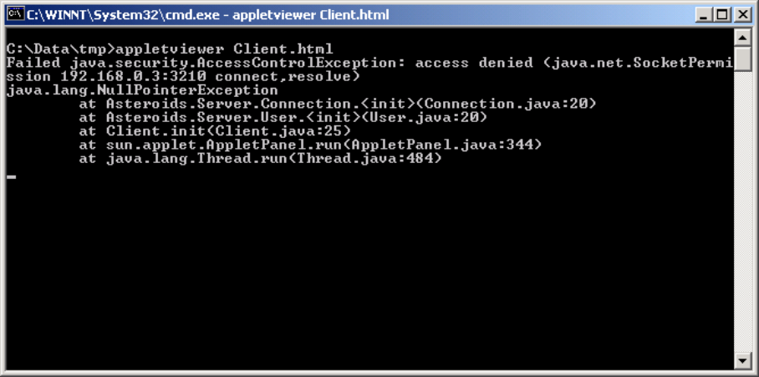

So to fix this problem, the game is hosted on a web server and the client then connects to the server from where the applet was downloaded.

Jumpy game objects

There was a major problem concerning jumpy game objects, they would just be jumping over the game area, instead of moving slowly. The fix was to put a thread into the client and every sixty milliseconds get the client to send a command to the server, this command will be rejected by the server as it is an unknown command. In sending this command, all that is happening is the client is writing at socket level to the server, server receives the command and ignores it. This could be a problem with the hardware or operating system that Asteroids was implemented on.

High CPU usage

On the server side CPU usage is fine, there were no problems. However on the client side, CPU usage is a bit on the high side. (See screenshot below)

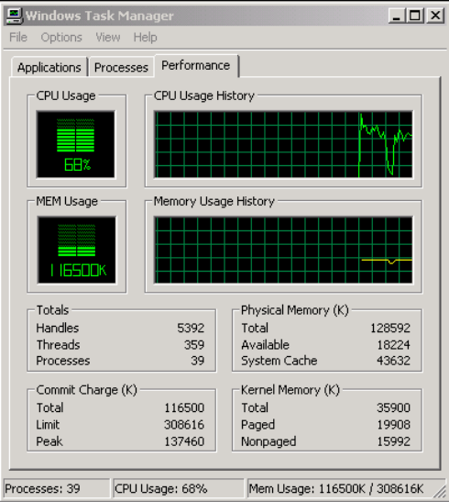

This isn’t a major problem; it is due that the vector graphics consume a lot of resources, including CPU power. In future releases of Asteroids optimization of the graphics should be a high priority to get the CPU usage down to a reasonable level.

Chapter | Testing
7 | Testing

7.1 Objectives
Objectives: The intention here is finding an error within the execution of the program. The objectives can be stated in two basic questions.

- Does the logic work properly?
- Is all the necessary logic present?

7.2 Testing Strategy
There are numerous strategies that could be undertook, they would include:

Unit Testing
The goal is to test each module to ensure that, it is coded and that it functions correctly.

Integration Testing
This involves testing groups of modules with the aim of ensuring that the subsystem functions correctly, and that the interfaces are correct.

Acceptance Testing
The finished system is tested by the sponsor to ensure that it is ready for use.

Due to time constraints, integration testing will be conducted on Asteroids. Future unit testing could be conducted by using a self-governing test program that performs operations on each functional component verifying if each user operation satisfies the pre and post conditions set out in the Functional Specification.

7.3 Testing Plan
The test plan aims to test numerous scenarios that are either normal or exceptional. A series of functional test cases will be designed to go through as many of the scenarios or logic paths as possible in the system.
Normal test cases are model cases where the system receives valid test and returns expected results. However, there are no exceptional test cases for this system. Erroneous data cannot be passed between the client and the server.
An error could occur at the socket level, but this is dealt at the operating system level.
A common template for our test plan will include the following:

- Purpose of the test
What the objective is, and what part of the system is being tested.
- Test Description
What the input to the test will be, and the expected result of the test
- Test Procedures
How the test data are prepared, how the output results are captured, and how the test results will be analyzed.

The following system components are the major testing areas:

- Server Side
- Client Side

7.4 Test Environment
As detailed in the design document the system incorporates two-tier architecture, consisting of a client and a server.

7.4.1 Server Testing Environment
We could the server on many different environments such as Unix, Linux, Apple Macintosh or any device that supports a Java Runtime Environment. I have selected Windows NT 4.0 as the chosen testing environment.

Specifications of testing environment:
- AMD Thunderbird 1.4Ghz
- 512Mb RAM
- Graphics card (Resolution: 1024 x 768)
- Windows 2000 with service pack 1
- Java 1.3.1 Run time environment
- SimpleServer.www configured and setup according to documentation.
- 10Mb Ethernet Card

The server is identified with the IP address of 192.168.0.1, listening for a client request on port 3021.

7.4.2 Client Testing Environment
The client is an applet driven application, so it could be run on numerous platforms and applications, such as Internet Explorer, Netscape and Sun’s AppletViewer. Appletviewer will be the main application to test Asteroids on. Due to time constraints Netscape and Internet Explorer will not be tested on.

Specifications of testing environment:
- Intel Pentium 933Mhz
- 128Mb RAM
- Windows 2000 with service pack 1
- Java 1.3.1. Runtime Environment

7.5 Server Side Test Cases
Test 1
Test Case | Start up Server
Objective | Ensure that the server initializes
Component Test | Server side
Test Method | - Load up a dos session  - At the Command line type java Asteroids.Server.Server  (See user guide for more documentation)
Test Input | n/a
Expected Test Output | Server shows the startup messages

Test 2
Test Case | Client Connects to server
Objective | Ensure that the client connects  - Client connects  - Should see a connect dialog  - Connect as many clients as possible  - When client limit is exceeded, an error should be displayed on the server dialog.
Component Test | Server side
Test Method | - Make a connection to the server using the client
Test Input | n/a
Expected Test Output | Server shows user connected message

Test 3
Test Case | Client disconnects from server
Objective | Ensure that the client is removed from server
Component Test | Server side
Test Method | - Carry on from test 2  - Close connection
Test Input | n/a
Expected Test Output | Server shows user removed message

Test 4
Test Case | Server Closes while game is running
Objective | Ensure that the client closes successfully
Component Test | Server side
Test Method | - Carry on from test 2  - Close server by hitting control-c
Test Input | Control-C
Expected Test Output | Server shuts down, and client closes in a fashioned matter

Test 5
Test Case | All asteroids are shot, a new batch is created
Objective | Ensure that the new batch of asteroids are created
Component Test | Server side
Test Method | - Carry on from test 2  - Clients destroy all asteroids (see client testing))
Test Input | n/a
Expected Test Output | A server message should appear saying that a new batch of asteroids was created.

7.6 Client Side Test Cases
7.6.1 Asteroids Client

Test 1
Test Case | Client connects to server
Objective | To test does the game load up upon connection
Component Test | Client side
Test Method | - Load up a dos session  - At the command line type: appletviewer http://<server-ip>
Test Input | n/a
Expected Test Output | Game should load up and user see asteroids, ships and lasers

7.6.2 Ship

Test 1
Test Case | Client accelerates ship
Objective | To test the acceleration of the ship
Component Test | Client side
Test Method | - Continue from 10.5.1 test 1  - Accelerate the ship by hitting the up arrow  (See user guide for more documentation if needed)
Test Input | Up arrow
Expected Test Output | Ship should accelerate to a maximum velocity

Test 2
Test Case | Client decelerates ship
Objective | To test the deceleration of the ship
Component Test | Client side
Test Method | - Continue from 10.5.1 test 1  - Turn the ship 180 degrees  - Accelerate the ship by hitting the up arrow  (See user guide for more documentation if needed)
Test Input | Up arrow
Expected Test Output | Ship should decelerate to 0, then start accelerating

Test 3
Test Case | Client turns ship left
Objective | To test the turning of the ship to the left
Component Test | Client side
Test Method | - Continue from 10.5.1 test 1  - Turn the ship left by hitting left arrow
Test Input | Left arrow
Expected Test Output | Ship should keep turning left while key pressed

Test 4
Test Case | Client turns ship right
Objective | To test the turning of the ship to the right
Component Test | Client side
Test Method | - Continue from 10.5.1 test 1  - Turn the ship right by hitting the right arrow
Test Input | Left arrow
Expected Test Output | Ship should keep turning right while key pressed

Test 5
Test Case | Invincible ship
Objective | To test whether a ship is invincible
Component Test | Client side
Test Method | - Continue from 10.5.1 test 1  - Ship should be flashing when connected to game
Test Input | n/a
Expected Test Output | Ship should stay invincible  - A ship is invincible while it is flashing

7.6.3 Client Laser

Test 1
Test Case | Create a laser pulse
Objective | To test if the laser is create and goes off in the right direction
Component Test | Client side
Test Method | - Continue from 10.5.1 test 1  - Face any direction  - Hit spacebar to shoot laser
Test Input | Spacebar
Expected Test Output | A laser should be created and start moving on the screen. Laser should be same colour as the ship

Test 2
Test Case | Remove a laser
Objective | To see if a laser will be removed from the gaming area after a period of time
Component Test | Client side
Test Method | - Continue on from 10.5.3 test 1
Test Input | Spacebar
Expected Test Output | A laser should be created it will travel for some time before it is removed from the game

7.6.4 Asteroid

Test 1
Test Case | Testing to see if a Asteroid is created
Objective | Testing to see if:  - Is the asteroid created ok  - random jaggy edges,  - coloured white.  - Move random velocity in x and y direction
Component Test | Client side
Test Method | - Continue on from 10.5.1 test 1
Test Input | n/a
Expected Test Output | Asteroid should be drawn with jagged edges, be coloured white and move in a random direction with a random speed.

Test 2
Test Case | Testing to see if a Asteroid is successfully split in two
Objective | Testing to see if when the asteroid is shot:  - It is removed from the gaming area  - It is split into two smaller asteroids each with random velocities  - The laser is removed
Component Test | Client side
Test Method | - Continue on with 10.5.4 test 1  - Aim ship at an asteroid  - hit space bar to shoot a laser at asteroid
Test Input | n/a
Expected Test Output | The big asteroid should be removed from the gaming area and replaced with two smaller asteroids. The laser should also be removed from the gaming area.

Test 3
Test Case | Testing to see if a small asteroid is removed from the gaming area
Objective | Testing to see if when the small asteroid is shot:  - It is removed from the gaming area  - Laser is removed from gaming area
Component Test | Client side
Test Method | - Continue on with 10.5.4 test 2
Test Input | n/a
Expected Test Output | The small asteroid and laser should be removed from the gaming area

7.6.5 Sounds

Test 1
Test Case | To see if the sounds are transferred from the server to the client upon client connection
Objective | Client connects to game and should download the sounds
Component Test | Client side
Test Method | - Continue on from10.5.1 test 1
Test Input | n/a
Expected Test Output | Sounds should be transferred

Test 2
Test Case | Laser shot sound
Objective | Shoot a laser, client should hear a laser sound
Component Test | Client side
Test Method | - Continue on from 10.5.3 test 1
Test Input | Spacebar
Expected Test Output | Should hear a gun shot sound

Test 3
Test Case | Thrusters sound
Objective | Ship accelerates and you should hear a thruster sound
Component Test | Client side
Test Method | - Continue from 10.5.1 test 1
Test Input | Up arrow
Expected Test Output | Should hear a thruster sound

Test 4
Test Case | Crash sound
Objective | Ship collides with an asteroid, the crash sound should he heard
Component Test | Client side
Test Method | - Continue from 10.5.1 test 1  - Move ship into asteroid
Test Input | Up/left/right arrow
Expected Test Output | Should hear a collision sound

Test 5
Test Case | Explosion
Objective | Laser hits an asteroid, should hear an explosion sound
Component Test | Client side
Test Method | - Continue from 10.5.1 test 1  - Aim laser at an asteroid  - Hit spacebar
Test Input | Spacebar
Expected Test Output | Should hear an explosion sound

7.6.6 Multiple Clients

Test 1
Test Case | Multiple Clients
Objective | Connecting up to max clients
Component Test | Client side
Test Method | - Repeat 10.5.1 test 1, 4 times
Test Input | n/a
Expected Test Output | 4 users should connect

Test 2
Test Case | Ships right colour
Objective | To see if the ships are the right colour
Component Test | Client side
Test Method | - Continue on from 10.5.6 test 1
Test Input | n/a
Expected Test Output | Each ship should have an unique colour:  - Ship 0 – Blue  - Ship 1 – Red  - Ship 2 – Green  - Ship 3 – Orange

Test 3
Test Case | Asteroid positions
Objective | To check if each client sees the same asteroids position
Component Test | Client side
Test Method | - Continue on from 10.5.6 test 1
Test Input | n/a
Expected Test Output | Each client should see identical asteroids positions

Test 4
Test Case | Multiple Lasers
Objective | To check if each client can see other ships lasers
Component Test | Client side
Test Method | - Continue on from 10.5.6 test 1  - Shoot a laser
Test Input | n/a
Expected Test Output | Each ship’s laser should have an unique colour:  - Ship 0 – Blue  - Ship 1 – Red  - Ship 2 – Green  - Ship 3 – Orange  Each client should see each users lasers

Test 5
Test Case | Shoot asteroids
Objective | To check if an asteroid is shot that each client can see it
Component Test | Client side
Test Method | - Continue on from 10.5.6 test 1  - Aim laser at an asteroid and shoot
Test Input | n/a
Expected Test Output | Each asteroid that is shot will be split up into two and each client should be able to see the smaller asteroid

Test 6
Test Case | Shoot small asteroid
Objective | Shoot a small asteroid and check that it is removed from the gaming area
Component Test | Client side
Test Method | - Continue on from 10.5.6 test 1  - Aim laser at an asteroid and shoot
Test Input | n/a
Expected Test Output | Each small asteroid that is shot will be removed from the gaming area.

Test 7
Test Case | Ship collides with a big asteroid
Objective | User should lose a life
Component Test | Client side
Test Method | - Continue on from 10.5.6 test 1  - Move ship into an asteroid
Test Input | n/a
Expected Test Output | The following are expected:  - Ship is removed from the gaming area  - Ship is replaced with a random position  - Ship loses a life  - Ship is invincible  - Flashing message saying you lost a life

Test 8
Test Case | Ship collides with a small asteroid
Objective | User should lose a life
Component Test | Client side
Test Method | 1. Continue on from 10.5.6 test 1  2. Move ship into an asteroid
Test Input | Left/Right/Up arrows
Expected Test Output | The following are expected:  - Ship is removed from the gaming area  - Ship is replaced with a random position  - Ship loses a life  - Ship is invincible  - Flashing message saying you lost a life

Test 9
Test Case | Ship is shot by another ship
Objective | User should lose a life
Component Test | Client side
Test Method | - Continue on from 10.5.6 test 1  - Aim laser at another ship  - shoot laser
Test Input | Space bar
Expected Test Output | The following are expected:  - Ship is removed from the gaming area  - Ship is replaced with a random position  - Ship loses a life  - Ship is invincible  - Flashing message saying you lost a life

7.6.7 Scoring and Top score

Test 1
Test Case | Big Asteroid scoring
Objective | A test to see if the scoring is right for a big asteroid
Component Test | Client side
Test Method | - Continue on from 10.5.6 test 1  - Shoot a big asteroid
Test Input | Spacebar
Expected Test Output | The should expect just the user’s score to be updated by 30 points

Test 2
Test Case | Small Asteroid scoring
Objective | A test to see if the scoring is right for a small asteroid
Component Test | Client side
Test Method | - Continue on from 10.5.6 test 1  - Shoot a small asteroid
Test Input | n/a
Expected Test Output | The should expect just the user’s score to be updated by 50 points

Test 3
Test Case | Shooting ship scoring
Objective | A test to see if the scoring is right for shooting another ship
Component Test | Client side
Test Method | - Continue on from 10.5.6 test 1  - Shoot a ship with laser
Test Input | Spacebar
Expected Test Output | The should expect just the user’s score to be updated by 100 points

Test 4
Test Case | Top score
Objective | To test if the top score system works, that is the top score is displayed along with user id.
Component Test | Client side
Test Method | - Continue on from 10.5.6 test 1  - Shoot asteroids  - Shoot Ships
Test Input | n/a
Expected Test Output | Should display top score and the user id

7.6.8 Game over

Test 1
Test Case | User loses all their lives
Objective | To see what happens when a user loses all their lives
Component Test | Client side
Test Method | - Continue on from 10.5.6 test 1  - Move ship into asteroid or get shot by another ship
Test Input | n/a
Expected Test Output | The following are expected:  - Game over message displayed on client  - Client cannot accelerate or move their ship

Test 2
Test Case | All the users game are over
Objective | To see what happens when all users die
Component Test | Client side
Test Method | - Continue on from 10.5.6 test 1  - All users lose their lives (see 10.5.8 test 1)
Test Input | n/a
Expected Test Output | The following are expected:  - Game over message displayed on client  - Client cannot accelerate or move their ship  - A message is displayed saying who won the game

7.7 Extensive game testing
A game play test will now be performed. That is the game server will be running over a period of time and several users will come in, play the game for a while and leave. There are a total of four people taking part, any errors or problems that arise will be fully documented in this section.

See appendix for results.

Chapter | Conclusion
8 | Conclusion

8.1 Evaluation of the final system
Overall I am happy with how the system has been implemented. The backbone of the system is fully functional, the next section talks about how you could develop the system even more (no software is ever complete!).

The testing went very well and only a few bugs showed up in the final build of the system, but they are low priority bugs and do not cause the system to run incorrectly.

Jumpy thruster sound
The sound is jumpy because when you hold down the up arrow the sound is played, so if you hold it down, you keep playing the sound. This is easily fixed with putting a delay function into the code

Shooting another ship – has to be a very accurate shot
Even thought that this is a minor problem, it will be a hard problem to fix.

Lose more lives even when your game is over
When your game is over, the ship is suspended but the CommandDispatcher still checks the suspended ship for collisions.

Lose two lives instead of the normal one live
This is caused by synchronization problem, where the ship hasn’t become invincible by the time the CommandDispatcher comes to do a check on collisions.

Due to heavy time constraints it was not possible to go back and alter my design; instead these low priority bugs have been noted and will be fixed in future releases of Asteroids.

8.2 Maximum number of users/asteroids
Maximum number of users
I went for a maximum of 4 users for the system; this was mainly because anymore than four on a 500x500 playing area it would get a bit congested.
Maximum number of asteroids
I went for a maximum number of 5 asteroids, again this was mainly due to the limited size of the playing area, any less and the game would be too easy and anymore it would be getting too tricky.

8.3 Further work to the system
There are so many features which could have been added to the system, they would have included:
Users
- User’s have to logon to the system using a login and password.
- If the user incorrectly enters the login/password three times, then they are locked out of the game for an amount of time.
- User’s should be able to change their controls from the predefined controls (arrow keys)
- User’s should be able to setup their own player name, instead of being assigned a number
Chat Server
- Chat server should be implemented so that user’s can chat to each other.
Gaming Area
- A scrollable gaming area could be implemented instead of the predefined 500x500 pixels.
- A background on the gaming area, instead of the black background with white random points forming stars.

Animation
- When the ship is accelerating some animation could be applied so that it looks like jets of fire are coming out of the rear of the ship
- When the ship collides or is destroyed by another ship, animation could be applied to the ship showing it blowing up.

Modes of Play
- Instead of the “free for all” mode that was implemented, a team play mode could be introduced to the game, where teams of ships battle it out.
Computer controlled objects
- The computer could control some of the ships when user’s aren’t logged in.
- Also some enemy UFOs could be introduced, these would be controlled by the computer
Ship
- Different types of weapons could be introduced, instead of just a single laser.
- The ship could be upgraded during the course of the game:
  - Greater value for maximum velocity
  - Instead of turning the ship 15 degrees, this could be changed during the course of the game to refine the ship movement (upgrading ship).

8.4 Platform Evaluation
To develop the system, Microsoft Windows 2000 (Service Pack 1) was used. It was adequate and provided a stable developing environment. To write the software JPad pro 4.0 (provided by ModelWorks) was used, an excellent IDE.
It would have been nice to test the system on other platforms, such as UNIX. But due to time constraints and resources available to me this was not possible.
The system used for development was an AMD 1.4GHz with 512mb RAM. Any system that ran Asteroids used a resolution of 1024 x 768 and 1280 x 1024.
I feel that JAVA was still the right decision in making this game as there was an awful lot of resources available, both on the internet and Queens University. However, in the development of such a graphically based system, C++ probably would have been an overall better programming language to implement the system in. If you look at today’s game market, 99% of the games are implemented in C++.

8.5 Testing Conclusion
From the test results, it is apparent that there are a few minor bugs in the system.

The minor bugs (low priority bugs) include:
- Jumpy thruster sound
- Shooting another ship – has to be a very accurate shot
- Lose more lives even when your game is over
- Lose two lives instead of the normal one live

I would have liked to test Asteroids on Internet Explorer and Netscape Navigator, but due to heavy time constraints this could not be accomplished.

It would also off been nice to test Asteroids on handheld devices, such as PDA devices and mobile phones. Maybe users could play against each other on the phones while they are traveling to work in a bus, just a thought.

Appendix | Test Results
A | Test Results

A.1 Server Side Test Results
Test 1
Actual Test Output | As expected, see screenshot below
Test Status | Successful

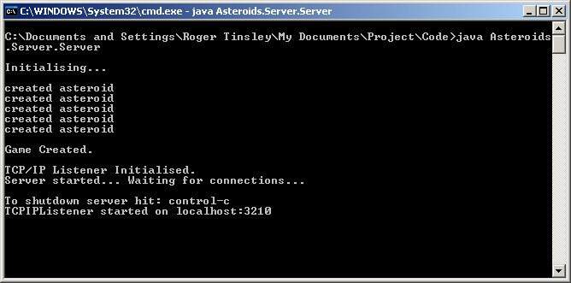
Test 2
Actual Test Output | As expected, see screenshot below
Test Status | Successful

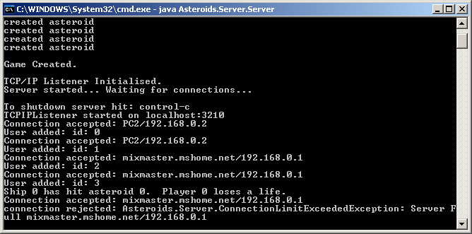

Test 3
Actual Test Output | As expected, see screenshot below
Test Status | Successful

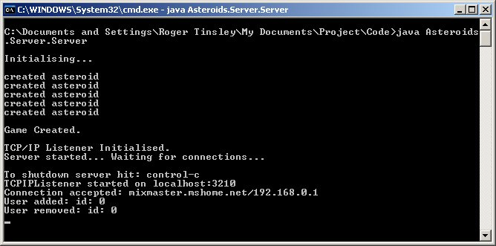

Test 4
Actual Test Output | As expected
Test Status | Successful

Test 5
Actual Test Output | As expected
Test Status | Successful

A.2 Client Side Test Results
A.2.1 Asteroids Client

Test 1
Actual Test Output | As expected, see screenshot below
Test Status | Successful

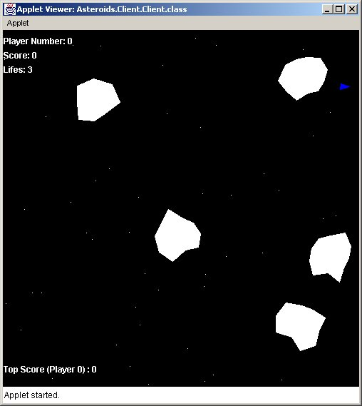
A.2.2 Ship

Test 1
Actual Test Output | As expected. No need for a screenshot
Test Status | Successful
Test 2
Actual Test Output | As expected. No need for a screenshot
Test Status | Successful

Test 3
Actual Test Output | As expected. No need for a screenshot
Test Status | Successful

Test 4
Actual Test Output | As expected. No need for a screenshot
Test Status | Successful

Test 5
Actual Test Output | As expected. No need for a screenshot
Test Status | Successful

A.2.3 Client Laser

Test 1
Actual Test Output | As expected. See screenshot (Note: Hard to see as the screenshot quality is poor)
Test Status | Successful

Test 2
Actual Test Output | As expected. No need for a screenshot
Test Status | Successful

A.2.4 Asteroid

Test 1
Actual Test Output | As expected. See screenshot
Test Status | Successful

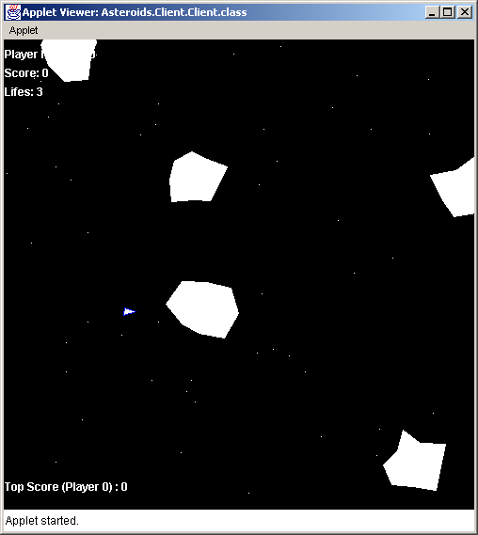

Test 2
Actual Test Output | As expected. See screenshot
Test Status | Successful

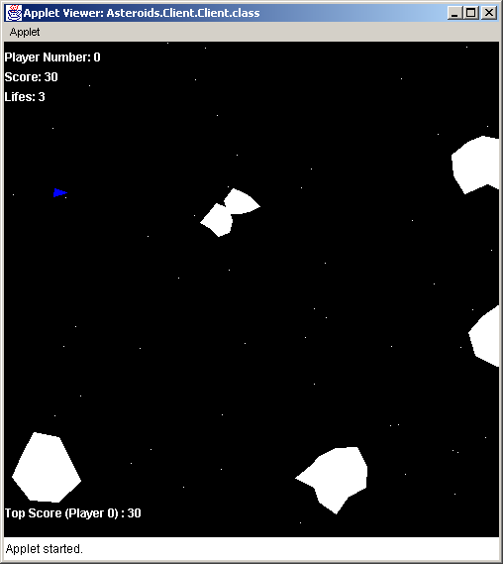
Test 3
Actual Test Output | As expected. No need for a screenshot
Test Status | Successful

A.2.5 Sounds

Test 1
Actual Test Output | Cannot say, there is no message saying this is true. Testing to see if sounds are present by shooting laser/collisions etc.
Test Status | Unknown

Test 2
Actual Test Output | As expected.
Test Status | Successful

Test 3
Actual Test Output | Thruster sound is heard, but appears a bit jumpy when you hold down up arrow.
Test Status | Successful

Test 4
Actual Test Output | As expected
Test Status | Successful

Test 5
Actual Test Output | As expected
Test Status | Successful

A.2.6 Multiple Clients

Test 1
Actual Test Output | As expected. See screenshot
Test Status | Successful

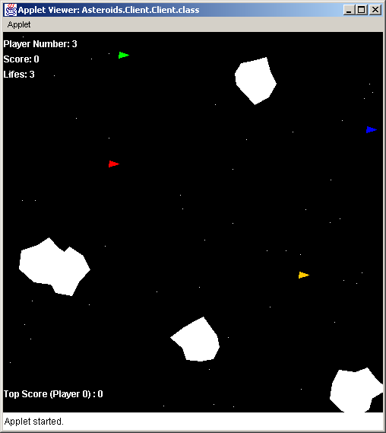

Test 2
Actual Test Output | As expected. See screenshot above
Test Status | Successful

Test 3
Actual Test Output | As expected.
Test Status | Successful

Test 4
Actual Test Output | As expected.
Test Status | Successful

Test 5
Actual Test Output | As expected. See screenshot
Test Status | Successful

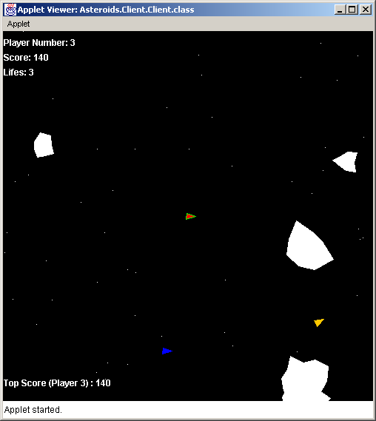

Test 6
Actual Test Output | As expected.
Test Status | Successful

Test 7
Actual Test Output | As expected.
Test Status | Successful

Test 8
Actual Test Output | As expected.
Test Status | Successful

Test 9
Actual Test Output | As expected, but, the shot needs to be extremely precise.
Test Status | Successful

A.2.7 Scoring and Top score

Test 1
Actual Test Output | As expected.
Test Status | Successful

Test 2
Actual Test Output | As expected.
Test Status | Successful

Test 3
Actual Test Output | As expected.
Test Status | Successful

Test 4
Actual Test Output | As expected. See screenshot
Test Status | Successful

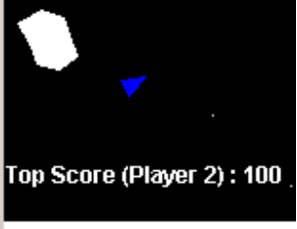

A.2.8 Game over

Test 1
Actual Test Output | As expected. See screenshot
Test Status | Successful

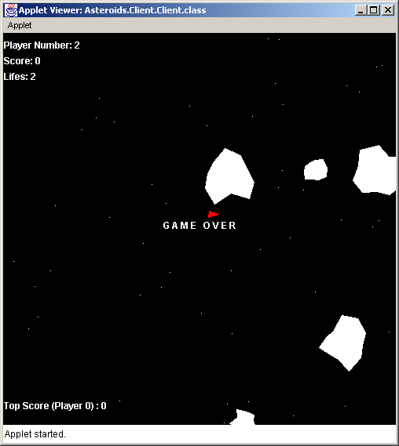

Test 2
Actual Test Output | As expected. See screenshot
Test Status | Successful

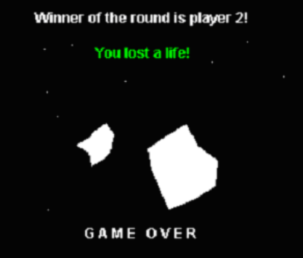

A.3 Extensive game testing results
User keeps losing lives when out of game
This problem occurs when the user is out of the game, and the server is still checking the user for collisions. When the user’s game is over, the ship is still on the game area, but is not painted as it is inactive.

This is not a serious problem, due to time constraints this cannot be fixed at this time. But it is documented as a known bug as will be fixed in future releases.

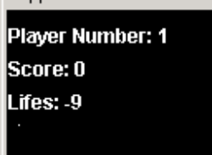

User lost two lives instead of one.
While playing the game, a user lost two lives instead of the normal one. This is a rare bug and only popped up once or twice during the extensive game testing. It could be due to synchronization problems on the server, the problem has not been investigated fully and due to time constraints it won’t be investigated.

This has been documented as a bug and it will be fixed in a future release of Asteroids.

Appendix | UML
B | UML

B.1 Client-side UML diagram
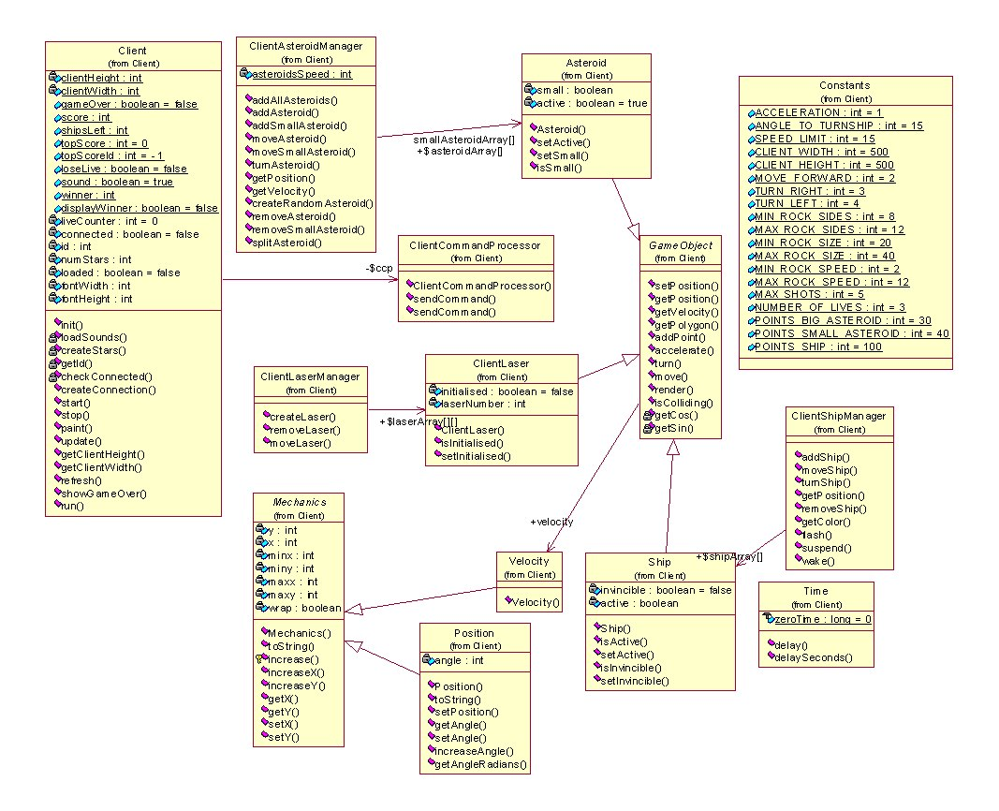

B.2 Server-side UML diagram
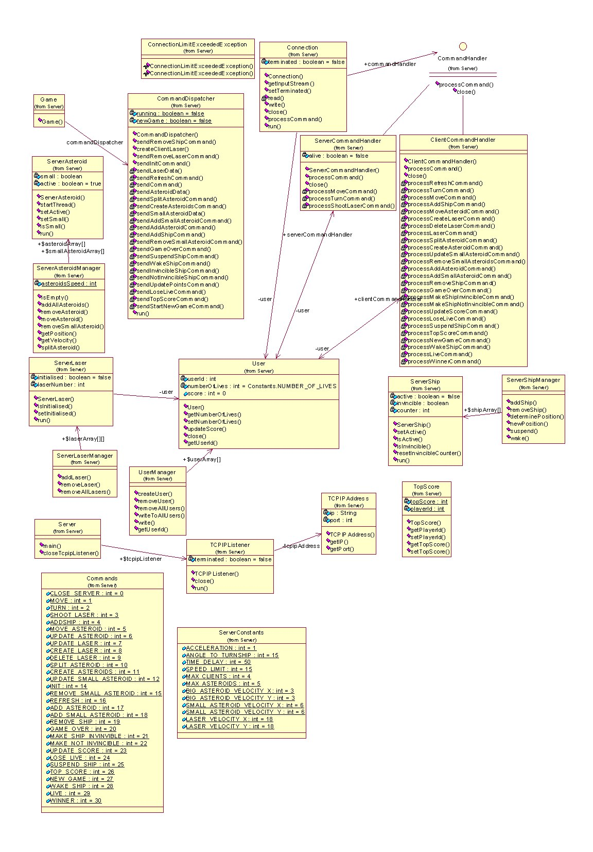
Appendix | User Guide
C | User Guide

C.1 Introduction
This section will show users how to setup the system and get it running.

C.2 Installing & Setting up the Server
- Run the provided installer (Asteroids.exe).
- Go to the directory that Asteroids was installed to (default directory c:\Asteroids).
- Edit the file RunServer.bat (Right click on the file and choose edit)
- Edit the JAVAHOME line to point to where Java is installed on your system.
- Navigate to the SimpleServer directory and run the http executable file.
- Click on the middle button at the bottom and select the file index.html within the Asteroids directory.
- Finally click start to start up the web server.
- To start up the Asteroids server, navigate through the start menu to the Asteroids section and execute run server. You should see several messages on the server window illustrating that the server is up and running and waiting for incoming connections.
Note: The server runs on port 3210, so if you have any other applications using this port please disable them.

C.3 Connecting with the client
- To connect to the server, start a new DOS command prompt session. (Start menu/programs/command prompt, also make sure your java virtual machine is setup)
- To see instructions on how to play the game, in a web browser go to the following url: http://<server_ip>/index.html
- To play the game, type appletviewer http://<server_ip>/game.html

C.4 Controlling the ship
Accelerating the ship: To accelerate press the up arrow on the keyboard.
Turning the ship left: To turn the ship left, press the left arrow on the keyboard
Turning the ship right: To turn the ship right press the right arrow on the keyboard.
Shooting the laser: To shoot the laser hit the space bar.
Turn sound on/off: To turn the sound on or off, hit the “s” button on the keyboard.
Decelerating the ship: To decelerate the ship, you have to turn the ship in completely the opposite direction and accelerate (there are no such things in space as brakes!)

C.5 Troubleshooting
C.5.1 Server-side
Error creating ServerSocket: java.net.BindException: Address in use: JVM_Bind
This problem occurs when you are trying to run two or more Asteroids server on the same local PC. Or, you have other software running that is bind to port 3210. Disable this software or close all instances of Asteroids.
C.5.2 Client-side
I type appletviewer http://IP/game.html and nothing happens?
The server administrator mustn’t of enabled the SimpleServer web server, get in contact with the administrator and get them to enable the web server.
Server full message appears, what’s up?
This message means that all the connections to the server are used, try connecting later.
I don’t have any sounds, please help!
It is highly unlikely that any sound problems is associated with Asteroids, it could be that your operating system hasn’t initialized your soundcard, please check your operating system guide.

Appendix | References
D | References

Third Edition: Java How to program by Dietel & Dietel

Java: Network programming by Merlin and Conrad Hughes, Michael Shoffner and Maria Winslow

Computing concepts with Java essentials by Cay Horstmann

http://www.cs.qub.ac.uk/~NS.Scott/csc321 - Excellent notes provided by Dr S. Scott on Threads/monitors in java.

http://java.sun.com/docs/ - Excellent documents on various aspects of Java, very useful.

http://java.sun.com/j2se/1.3/docs/api/index.html - A priceless resource of information

Appendix | Source Code
E | Source Code

